# Overview

This document contains the necessary information to build the LipSync. The Maker Checklist outlines the required steps, including questions for the User. The Tool List contains a comprehensive list of all tools and supplies required to complete the build. The Custom PCB contains information on how to order the required printed circuit board (PCB). The 3D Printing Guide contains print settings and quantities for the 3D printed components. The Assembly Guide contains all the necessary steps to assemble and program the device. Finally, the Testing Guide contains a set of tests to confirm the LipSync is working properly.

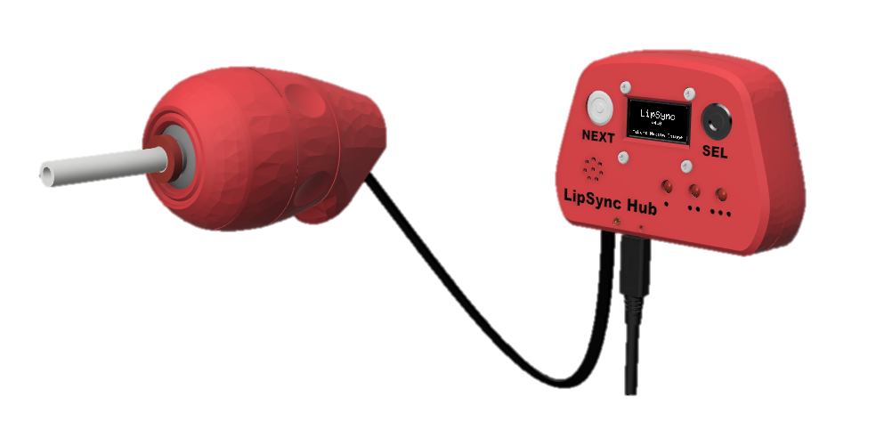

Contents

Overview 1

Maker Checklist 5

Maker To Do List 5

Items to Give to User 5

Tool List 6

Tools/ Equipment 6

Supplies 6

Custom PCB Guide 7

Ordering the Custom PCB 7

3D Printing Guide 8

3D Printing Summary 8

3D Printing Settings 8

Customization Options 9

Joystick 9

Hub 9

Post-Processing 10

Examples of Quality Prints 10

Master Component List 12

Assembly Guide 21

Part A: Hub PCB Assembly 23

Part A: Components 23

Part A: Tools 24

Part A: Personal Protective Equipment (PPE) 24

Part A: Hub PCB Assembly Steps 25

Part B: Hub Enclosure Assembly 32

Part B: Components 32

Part B: Tools 33

Part B: Personal Protective Equipment (PPE) 33

Part B: Assembling Hub Enclosure Steps 34

Part C: Mouthpiece Assembly 39

Part C: Components 39

Part C: Tools 39

Part C: Personal Protective Equipment (PPE) 39

Part C: Assembling the Mouthpiece Steps 40

Part D: Joystick Gimbal Assembly 44

Part D: Components 44

Part D: Tools 45

Part D: Personal Protective Equipment (PPE) 45

Part D: Joystick Gimbal Assembly Steps 46

Part E: Joystick Housing Assembly 58

Part E: Components 58

Part E: Tools 59

Part E: Personal Protective Equipment (PPE) 59

Part E: Assembling Joystick Housing Steps 60

Part F: Flashing Firmware to Hub 72

Part F: Components 72

Part F: Tools 72

Part F: Firmware Flashing Steps 73

Part G: Initial LipSync Setup and Testing 75

Part G: Components 75

Part G: Initial LipSync Setup Steps 75

Troubleshooting 76

Part H: Hub Stand Assembly 77

Part H: Components 77

Part H: Hub Assembly Steps 77

Testing Guide 79

Testing the LipSync 79

Testing Mouse Mode 79

Testing Sip and Puff 79

Testing External Switches 80

Testing Hub Buttons 80

# Maker Checklist

This list provides an overview of the steps required to build and deliver the device.

## Maker To Do List

* Read through the Maker Guide to become familiar with required components, tools, supplies, safety equipment, and overall assembly steps.
* Talk to User about customization options (e.g., color, any special requests, etc.)
  + Hub Color
  + Joystick Color
  + Default hub stand or the LipSync Hub Modular Mounting System
* Order Custom PCBs.
* Order hardware components.
* Print 3D printed components.
* Gather tools, supplies, and safety equipment.
* Assemble the LipSync Hub.
* Assemble the LipSync Joystick.
* Assemble the LipSync Mouthpieces.
* Assemble and flash firmware to the LipSync
* Test the LipSync.
* Print LipSync User Guide

## Items to Give to User

* (1) LipSync Joystick. Assembled and tested.
* (1) LipSync Hub. Assembled, flashed, and tested.
* (1) LipSync Interface Cable.
* (1) USB-C Cable.
* (5) Mouthpiece Assemblies.
* Printed LipSync User Guide.

# Tool List

### Tools/ Equipment

|  |  |  |  |
| --- | --- | --- | --- |
| Tool | Description |  | Notes |
| T01 | Soldering Iron | Required | For soldering electronic components. |
| T02 | Flush cutters | Required | For trimming soldered leads |
| T03 | Needle Nose Pliers | Recommended | Installing bearings; routing cables. |
| T04 | Crescent wrench / wrench / hex key | Recommended | For installing T-nuts into Hub and Joystick enclosures. |
| T05 | Screwdriver, Phillips, Small | Required | A jeweller’s screwdriver or similar for securing M2.5 machine screws. |
| T06 | Sandpaper / Files | Recommended | Cleaning up 3d prints; fixing bearing fits |
| T07 | Computer with Arduino IDE | Required | For flashing firmware to microcontroller |

### Supplies

|  |  |  |  |
| --- | --- | --- | --- |
| Supplies ID | Description | Quantity | Notes |
| S01 | Solder |  |  |
| S02 | Food safe silicone adhesive |  |  |

# Custom PCB Guide

The LipSync V4.0 uses one (1) custom circuit board for the Hub.

The Custom PCB can be ordered from one of a variety of PCB Manufacturers. Typically, the minimum quantity for a custom PCB is five. Shipping options vary significantly in cost and shipping time. Plan on at least a week from the time of order to the PCBs arrival.

## Ordering the Custom PCB

1. Select a PCB Fabrication Company
   1. [JLPCB](https://jlcpcb.com/)
   2. [PCBWay](https://www.pcbway.com/)
   3. [OSH Park](https://oshpark.com/)
   4. [Seeed Fusion PCB](https://www.seeedstudio.com/fusion_pcb.html)
2. Create an account or use a guest login.
3. Upload the Gerber Files (e.g., LipSync_Hub_PCB_YYY-MM-DD.zip).
4. Select the fabrication options:
   1. PCB Layers: 2 Layers
   2. PCB Quantity: 5
   3. PCB Thickness: 1.5 mm
   4. Surface Finish: HASL
   5. PCB Color: Choose what you like. Note that certain colors may impact build time.
   6. The default settings for the other settings should work.
5. Select shipping option.
   1. Shipping options and costs vary significantly. Select the best option based on your budget and timing.
6. Submit the order.

# 3D Printing Guide

## 3D Printing Summary

|  |  |  |  |
| --- | --- | --- | --- |
| **Metrics** | **LipSync Hub** | **LipSync Joystick** | **Complete Unit** |
| Total Print Time (min) | 4:16 | 9:58 | 13:50 |
| Total Number of Components | 8 | 11 | 16 |
| Typical Total Mass (g) | 70 | 103 | 151 |
| Typical Number of Print Setups | 2 | 2 | 2 |

## 3D Printing Settings

Table 1: LipSync Joystick 3D Printing Settings

|  |  |  |  |  |  |  |  |
| --- | --- | --- | --- | --- | --- | --- | --- |
| **Print File Name** | **Qty** | **Total Print Time (hr:min)** | **Mass (g)** | **Infill (%)** | **Support**  **(Y/N)** | **Layer Height/ Nozzle Diameter(mm)** | **Notes** |
| LS4_Inner_Gimbal_1.stl | 1 | 0:29 | 3 | 20 | N | 0.2/0.4 | - You may require paint-on supports on the arm going to the magnet slot |
| LS4_Inner_Gimbal_2.stl | 1 | 0:30 | 3 | 20 | N | 0.2/0.4 | - You may require paint-on supports on the arm going to the magnet slot |
| LS4_Outer_Gimbal_1.stl | 1 | 0:19 | 2 | 20 | N | 0.2/0.4 |  |
| LS4_Outer_Gimbal_2.stl | 1 | 0:19 | 2 | 20 | N | 0.2/0.4 |  |
| LS4_Gimbal_Shield.stl | 1 | 0:18 | 4 | 20 | N | 0.2/0.4 |  |
| LS4_Magnet_Clip.stl | 2 | 0:02 | 1 | 20 | N | 0.2/0.4 |  |
| LS4_Gimbal_Sled.stl | 1 | 0:43 | 5 | 20 | N | 0.2/0.4 |  |
| LS4_Front_Cap.stl | 1 | 0:58 | 14 | 20 | N | 0.2/0.4 | Change outer seam to random |
| LS4_Joystick_Housing.stl | 1 | 2:05 | 27 | 20 | N | 0.2/0.4 | Change outer seam to random |
| LS4_Outer_Locking_Ring.stl | 1 | 1:15 | 17 | 20 | N | 0.2/0.4 | Change outer seam to random |
| LS4_Inner_Locking_Ring.stl | 1 | 0:33 | 6 | 20 | N | 0.2/0.4 |  |
| LS4_Rear_Housing.stl | 1 | 2:27 | 22 | 20 | N | 0.2/0.4 | Change outer seam to random |

Table 2: LipSync Hub 3D Printing Settings

|  |  |  |  |  |  |  |  |
| --- | --- | --- | --- | --- | --- | --- | --- |
| **Print File Name** | **Qty** | **Total Print Time (hr:min)** | **Mass (g)** | **Infill (%)** | **Support(Y/N)** | **Layer Height/ Nozzle Diameter(mm)** | **Notes** |
| LS4_Hub_Top | 1 | 1:34 | 20 | 15 | N | 0.2/0.4 |  |
| LS4_Hub_Bottom | 1 | 2:07 | 26 | 15 | N | 0.2/0.4 |  |
| LS4_Hub_LED_Spacer | 1 | 0:13 | 2 | 15 | N | 0.2/0.4 |  |
| LS4_Hub_Next_Button_Pusher | 1 | 0:11 | 1 | 15 | N | 0.2/0.4 |  |
| LS4_Hub_SEL_Button_Pusher | 1 | 0:11 | 1 | 15 | N | 0.2/0.4 |  |
| LS4_Hub_Stand_Front | 1 | 0:21 | 13 | 15 | N | 0.2/0.4 |  |
| LS4_Hub_Stand_Leg | 2 | 0:07 | 4 | 15 | N | 0.2/0.4 |  |

## Customization Options

### Joystick

Each outward facing component of the Joystick enclosure (Front Cap, Joystick Housing, Outer Locking Ring, and Rear Housing) can be printed in a combination of different or matching colors to customize the look of the LipSync Joystick. Otherwise, muted or neutral tones (e.g., black or grey) are generally preferred.

### Hub

There are several options for customizing the look of the LipSync Hub depending on the color(s) of the filament available.

#### Matching

Print the Hub Top, Hub Bottom, and both Buttons in the same color.

#### Different Colored Buttons

Print the buttons in a different color from the Hub Top, and optionally different from each other.

#### High Contrast Labels

Use a layer-based color swap so the labels are a different color than the surface of the Hub. This can be done on both the Hub Top and Hub Bottom. A second layer swap can be used to make the Hub Enclosure look consistent.

## Post-Processing

Remove any stringing or rough edges of parts with a hobby knife, seam remover, or other appropriate tool.

## Examples of Quality Prints

|  |  |  |
| --- | --- | --- |
| **Joystick** | | |
| LS4_Inner_Gimbal_1.stl | LS4_Inner_Gimbal_2.stl | LS4_Outer_Gimbal_1.stl |
| Inner gimbal 1 3D print | Inner gimbal 2 3D print | Outer gimbal 1 3D print |
| LS4_Outer_Gimbal_2.stl | LS4_Gimbal_Shield.stl | LS4_.Gimbal_Sled.stl |
| Outer gimbal 2 3D print | Gimbal shield 3D print | Sled 3D print |
| LS4_Magnet_Clip.stl | LS4_Front_Cap.stl | LS4_Joystick_Housing.stl |
| Magnet Retainment pin 3D print | Front Cap 3D print | Joystick enclosure 3D print |
| LS4_Inner_Locking_Ring.stl | LS4_Outer_Locking_Ring.stl | LS4_Rear_Housing.stl |
| Inner Locking ring 3D print | Outer locking ring 3D print | Rear enclosure 3D print |
| **Hub** | | |
| LS4_Hub_Bottom.stl | LS4_Hub_.stl | LS4_Hub_Next_Button.stl |
| Hub enclosure bottom 3D print, printed in red. | Hub enclosure top 3D print, printed in red with black text. | Good quality print of the Next button pusher, printed in red |
| LS4_Hub_Select_Button.stl | LS4_Hub_LED_Spacer.stl |
| Good quality print of the Select button pusher, printed in red | Good quality print of Hub LED spacer, printed in grey. |

# Master Component List

|  |  |  |  |  |  |  |  |  |  |  |  |  |  |  |  |  |  |  |
| --- | --- | --- | --- | --- | --- | --- | --- | --- | --- | --- | --- | --- | --- | --- | --- | --- | --- | --- |
| **Part A Components** | | | | | | | | | | | | | | | | | | |
| **A1** | LipSync Hub PCB | | | QTY 1 | **A2** | | | Capacitor, 10uF | | | QTY 1 | **A3** | Resistor R1, 100 Ω, ¼ W, Through hole | | | | | QTY 1 |
| LipSync Hub circuit board. | | | | | A yellow capacitor with a white background. | | | | | | | A resistor diagram showing the correct resistors A resistor diagram showing the correct resistors | | | | | | |
| **A4** | Resistor R2/R3/R4 68 Ω, ¼ W, Through hole | | | QTY 3 | **A5** | | | Tactile Buttons S1/S2 | | | QTY 2 | **A6** | Piezo Buzzer PS1240 | | | | | QTY 1 |
| A resistor diagram showing the correct resistors A resistor diagram showing the correct resistors | | | | | A photo of 1 tactile buttons on a white background. | | | | | | | A photo of a piezo buzzer on a white background. | | | | | | |
| **A7** | Male Header, 4 position | | | QTY 1 | **A8** | | | Sparkfun QWIIC Adapter | | | QTY 1 | **A9** | Mono Switch Jacks | | | | | QTY 3 |
| 4 pin male header | | | | | Sparkfun stemma adaptor breakout board | | | | | | | A 3.5 mm mono jack | | | | | | |
| **A10** | RJ11 Modular Connector Jack | | | QTY 1 | **A11** | | | SeeedStudio Xiao nrF52840 | | | QTY 1 | **A12** | Male Header, 7 position | | | | QTY 2 | |
| A RJ11 jack | | | | | A Xiao nrf52840 microcontroller | | | | | | | A male 7 pin header | | | | | | |
| **A13** | Headers, Female, 7 Position | | | QTY 2 | **A14** | | | LEDs, 5mm though hole | | | QTY 3 | **A15** | LipSync Hub LED Spacer | | | | QTY 1 | |
| A photo of two 7 pin female headers on a white background. | | | | | A red LED | | | | | | | LipSync Hub LED spacer | | | | | | |
| **Part B Components** | | | | | | | | | | | | | | | | | | |
| **B1** | Populated LipSync 4 Hub PCB | | | QTY 1 | **B2** | | | STEMMA QT Cable – 100 mm | | | QTY 1 | **B3** | OLED Display | | | QTY 1 | | |
| The LipSync 4 Hub circuit board, in red, with all components installed. | | | | | A 100 mm stemma cable | | | | | | | A LED display breakout board | | | | | | |
| **B4** | LipSync Hub Enclosure Top | | | QTY 1 | **B5** | | | LipSync Next Button Pusher | | | QTY 1 | **B6** | LipSync Select Button Pusher | | | QTY 1 | | |
| Hub top enclosure 3D print | | | | | A Lipsync next button pusher | | | | | | | A Lipsync select button pusher | | | | | | |
| **B7** | LipSync Hub Enclosure Bottom | | | QTY 1 | **B8** | | | Screw, #4, 3/8” Length | | | QTY 5 | **B9** | M2.5 Machine Screw, 8 mm | | | QTY 4 | | |
| Hub bottom enclosure 3D print | | | | | A photo of a #4 3/8" metal pan head screw on a white background. | | | | | | | A close-up of a M2.5 bolt | | | | | | |
| **B10** | M2.5 Nut | | | QTY 4 | **B12** | | | ¼-20 UNC Tee Nut | | | QTY 1 | **B13** | Light Pipe | | | QTY 1 | | |
| A close up of a M2.5 nut | | | | | A close up of the T-nut | | | | | | | A close up of the light pipe | | | | | | |
| **Part C Components** | | | | | | | | | | | | | | | | | | |
| **C1** | Syringe FIlter | | | QTY 6 | **C2** | | | Dental Straw | | | QTY 2 | **C3** | 2mm ID 4mm OD Tube | | QTY 6cm | | | |
| A close up of the syringe filter | | | | | A close up of the dental straw | | | | | | | Close up of a 2mm ID 4mm OD silicone tube | | | | | | |
| **C4** | Silicone Straw | | QTY 2 | | **C5** | Zip Tie | | | | QTY 6 | |
| Close up of a section of silicone straw | | | | | A close up image of a zip tie | | | | | | |
| **Part D Components** | | | | | | | | | | | | | | | | | | |
| **D1** | Inner_Gimbal_1 | | | QTY 1 | **D2** | | | Inner_Gimbal_2 | | | QTY 1 | **D3** | Outer_Gimbal_1 | | QTY 1 | | | |
| A close up of the inner gimbal 1 print | | | | | A close up of the inner gimbal 2 print | | | | | | | A close up of the outer gimbal 1 print | | | | | | |
| **D4** | Outer_Gimbal_2 | | | QTY 1 | **D5** | | | Gimbal Shield | | | QTY 1 | **D6** | Sled | | QTY 1 | | | |
| A close up of the outer gimbal 2 print | | | | | A close up of the gimbal shield print | | | | | | | A close up of the sled | | | | | | |
| **D7** | Magnet Retainment | | | QTY 2 | **D8** | | | LPS33 STEMMA QT Board | | | QTY 1 | **D9** | TLV493D STEMMA QT Board | | QTY 1 | | | |
| A close up of the magnetic retainment pin | | | | | A close up of the pressure sensor | | | | | | | A close up of the magnetic sensor | | | | | | |
| **D10** | Male Luer Connector | | | QTY 1 | **D11** | | | 2mm ID 4mm OD Tube | | | QTY 1 | **D12** | Cable, STEMMA, 200 mm | | QTY 1 | | | |
| A close up of the male Luer connector | | | | | Close up of a 2mm ID 4mm OD silicone tube | | | | | | | A close-up of a 200mm stemma cable | | | | | | |
| **D13** | Magnet | | | QTY 3 | **D14** | | | Bearings | | | QTY 4 | **D15** | Cable, STEMMA, 50 mm | | QTY 1 | | | |
| A close up photo of the magnet | | | | | A close-up of a metal bearing | | | | | | | A close-up of a 50mm stemma cable | | | | | | |
| **D16** | M2.5 Nut | | | QTY 2 | **D17** | | | M2.5 Machine Screw, 8 mm | | | QTY 2 |
| A close up of a M2.5 nut | | | | | A M2.5 Bolt | | | | | | |
| **Part E Components** | | | | | | | | | | | | | | | | | | |
| **E1** | Front Cap | | | QTY 1 | **E2** | | Joystick Housing | | | | QTY 1 | **E3** | Inner Locking Ring | | QTY 1 | | | |
| A photo of the Front Cap 3D print | | | | | A photo of the Joystick Housing | | | | | | | A photo of the inner LipSync locking ring | | | | | | |
| **E4** | Outer Locking Ring | | | QTY 1 | **E5** | | Rear Housing | | | | QTY 1 | **E6** | LPS22 STEMMA QT Board | | QTY 1 | | | |
| A photo of the LipSync outer locking ring | | | | | A photo of the Rear housing for the LipSync joystick | | | | | | | A photo of a LPS22 pressure sensor breakout board | | | | | | |
| **E7** | Cable, STEMMA – DuPont, 150 mm | | | QTY 1 | **E8** | | RJ11 Connector | | | | QTY 1 | **E9** | RJ11 Breakout Board | | QTY 1 | | | |
| A photo of a stemma to dupont cable | | | | | A photo of an RJ11 jack | | | | | | | A close up of two connected RJ11 breakout boards | | | | | | |
| **E10** | M2.5 Bolt | | | QTY 1 | **E11** | | M2.5 Nut | | | | QTY 1 | **E12** | Light Pipe 0.250” | | QTY 1 | | | |
| A close up of an M2.5 bolt | | | | | A close up of a M2.5 nut | | | | | | | A photo of a light pipe | | | | | | |
| **E13** | Assembled Joystick Gimbal | | | QTY 1 | **E14** | | ¼-20 T-nut | | | | QTY 1 | **E15** | Screw, #4, 3/8” Length | | QTY 3 | | | |
| A photo of the assembled gimbal joystick | | | | | A photo of a T-Nut | | | | | | | A photo of a #4 3/8" metal pan head screw on a white background. | | | | | | |
| **Part F Components** | | | | | | | | | | | | | | | | | | |
| **F1** | Assembled LipSync Joystick | QTY 1 | | | **F2** | | | Assembled LipSync Hub | QTY 1 | | | **F3** | RJ11 Cable | QTY 1 | | | | |
| The completed, assembled LipSync in a side view | | | | | Fully assembled LipSync Hub | | | | | | | A picture of the RJ11 cable | | | | | | |
| **F4** | USB-C-USB-A Cable | QTY 1 | | |
| A photo of a black USB-C cable on a white background. | | | | |
|  | | | | |

|  |  |  |  |  |  |  |  |  |  |  |
| --- | --- | --- | --- | --- | --- | --- | --- | --- | --- | --- |
| **Part G Components** | | | | | | | | | | |
| **G1** | | LipSync System | QTY 1 | **G2** | LipSync Mouthpiece | QTY 1 | **G3** | Host Device | QTY 1 | |
| A almost fully assembled LipSync joystick and hub, without the mouthpiece | | | | The finished mouthpiece assembly | | | Laptop outline | | | |
| **Part H Components** | | | | | | | | | | |
| **H1** | LS4_Hub_Stand_Front | | QTY 1 | **H2** | LS4_Hub_Stand_Leg | QTY 2 | **H3** | LipSync Hub | | QTY 1 |
| The front of the hub stand, printed in red | | | | A leg of the hub stand, printed in red | | | Fully assembled LipSync Hub | | | |

# Assembly Guide

The assembly of the LipSync is divided into several parts. In Part A, the Hub PCB is populated. In part B, the Hub PCB is assembled along with other components into the Hub Enclosure. In Part C, the mouthpiece components are assembled. In Part D, the joystick mechanism is assembled. In Part E, the joystick mechanism is assembled into the Joystick Enclosure. In Part F, the final firmware is loaded onto the device. In Part G, the LipSync is powered on and calibrated.

It is recommended to follow the assembly instructions in the order provided.

|  |  |
| --- | --- |
| Assembly Section |  |
| Part A: Hub PCB Assembly | LipSync circuit board with all components installed. |
| Part B: Hub Enclosure Assembly | Fully assembled LipSync Hub |
| Part C: Mouthpiece Assembly | The finished mouthpiece assembly |
| Part D: Joystick Gimbal Assembly | A photo of the final gimbal assembly |
| Part E: Joystick Housing Assembly | The completed, assembled LipSync in a side view |
| Part F: Flashing Firmware to Hub | A almost fully assembled LipSync joystick and hub, without the mouthpiece |
| Part G: Initial LipSync Setup and Testing | CAD render of final assembled LipSync Joystick and Hub |
| Part G: Initial LipSync Setup and Testing Hub Stand Assembly | LipSync Hub installed on the stand |

## Part A: Hub PCB Assembly

### Part A: Components

|  |  |  |  |  |  |  |  |  |  |
| --- | --- | --- | --- | --- | --- | --- | --- | --- | --- |
| **A1** | LipSync 4 Hub PCB | QTY 1 | **A2** | Capacitor, 10uF | QTY 1 | **A3** | Resistor R1, 100 Ω, ¼ W, Through hole | | QTY 1 |
| LipSync Hub circuit board.od. | | | A yellow capacitor with a white background. | | | A resistor diagram showing the correct resistors A resistor diagram showing the correct resistors | | | |
| **A4** | Resistor R2/R3/R4 68 Ω, ¼ W, Through hole | QTY 3 | **A5** | Tactile Buttons S1/S2 | QTY 2 | **A6** | Piezo Buzzer PS1240 | | QTY 1 |
| A resistor diagram showing the correct resistors A resistor diagram showing the correct resistors | | | A photo of 1 tactile buttons on a white background. | | | A photo of a piezo buzzer on a white background. | | | |
| **A7** | Male Header, 4 position | QTY 1 | **A8** | Sparkfun QWIIC Adapter | QTY 1 | **A9** | Mono Switch Jacks | | QTY 3 |
| 4 pin male header | | | Sparkfun stemma adaptor breakout board | | | A 3.5 mm mono jack | | | |
| **A10** | RJ11 Modular Connector Jack | QTY 1 | **A11** | SeeedStudio Xiao nrF52840 | QTY 1 | **A12** | Male Header, 7 position | QTY 2 | |
| A RJ11 jack | | | A Xiao nrf52840 microcontroller | | | A male 7 pin header | | | |
| **A13** | Headers, Female, 7 Position | QTY 2 | **A14** | LEDs, 5mm though hole | QTY 3 | **A15** | LipSync Hub LED Spacer | QTY 1 | |
| A photo of two 7 pin female headers on a white background. | | | A red LED | | | LipSync Hub LED spacer | | | |

### Part A: Tools

* Soldering iron
* Flush cutters
* Phillips Head Screwdriver
* OPTIONAL: Solderless Breadboard (For soldering male headers to microcontroller)

### Part A: Personal Protective Equipment (PPE)

* Safety glasses

### Part A: Hub PCB Assembly Steps

Note that all parts will be inserted onto the side of the PCB labeled “Front”, and all soldering will be done on the side labeled “Back”.

#### Step A-01: Solder in 10 micro Farad capacitor, C1.

Insert the 10 micro-Farad capacitor (A2) into the position labeled C1 on the PCB (A1). Bend the leads of the capacitor to the side to hold it in place. Solder the capacitor onto the PCB. Once soldered, trim the extra from the leads.

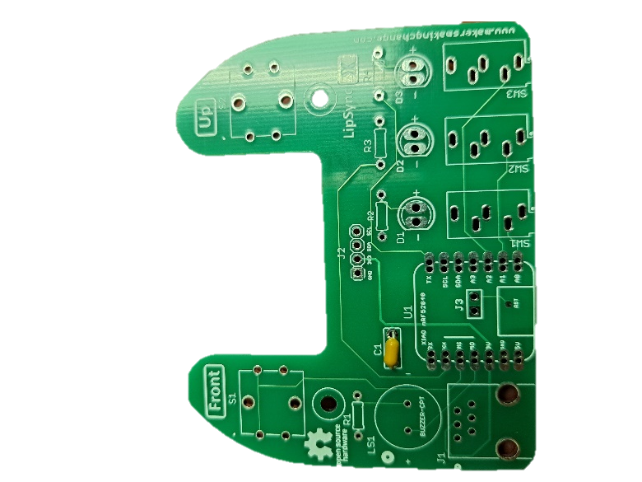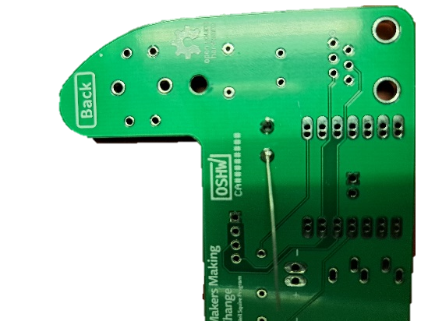

#### Step A-02: Solder in 100 Ohm resistor, R1.

Insert the 100 Ohm resistor (A3) into the position labeled R1 on the PCB. Bend the leads of the resistor to the side to hold it in place. Solder the resistor onto the PCB. Once soldered, trim the extra from the leads.

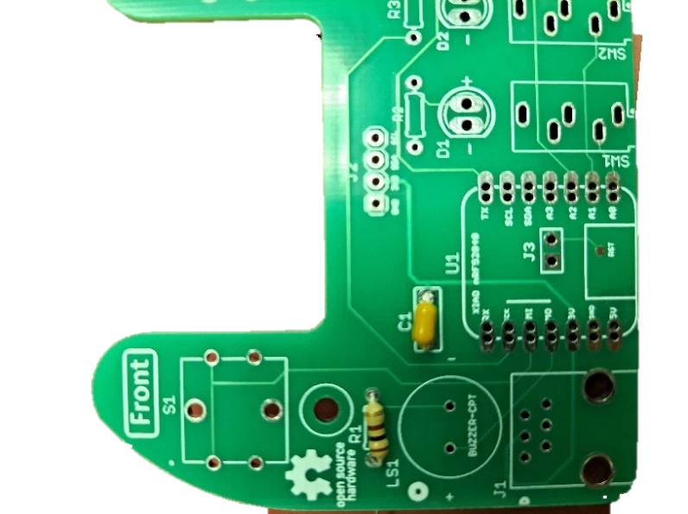

#### Step A-03: Solder in 68 Ohm resistors, R2, R3, and R4.

Insert the 68 Ohm resistors (A4) into the positions labeled R2, R3, and R4 on the PCB. Bend the leads of the resistors to the side to hold them in place. Solder the resistors onto the PCB. Once soldered, trim the extra from the leads.

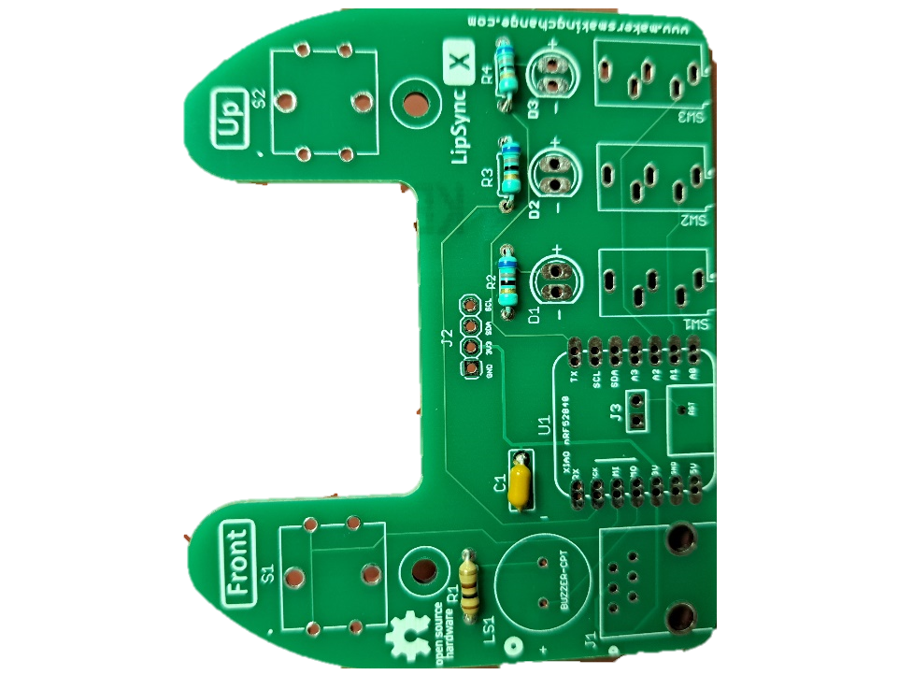

#### Step A-04: Insert, solder, and trim the 4-pin Male header.

Insert the longer pins of the 4-pin male header (A7) into the position labeled J2. Solder it into place and trim the excess from the bottom.

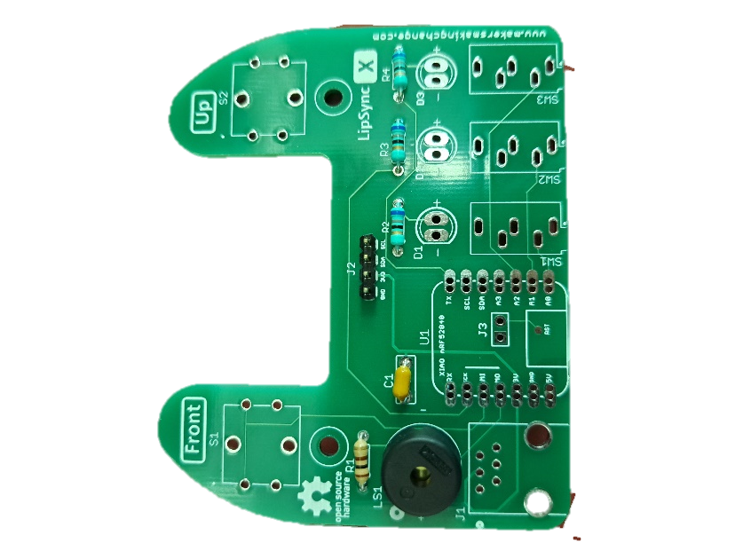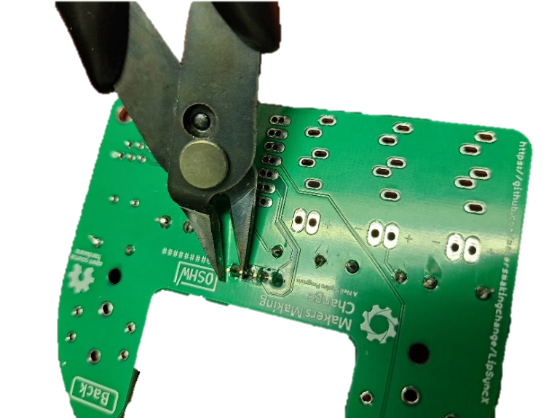

#### Step A-05: Insert, solder, and trim buzzer.

Insert the buzzer (A6) into the position labeled LS1. If using a buzzer with polarity, make sure the positive lead is in the hole marked with a “+” on the PCB. Note that the Piezo Buzzer PS1240 does not have polarity. Bend the leads to the side to hold the buzzer in place. Solder in place and trim excess from the leads.

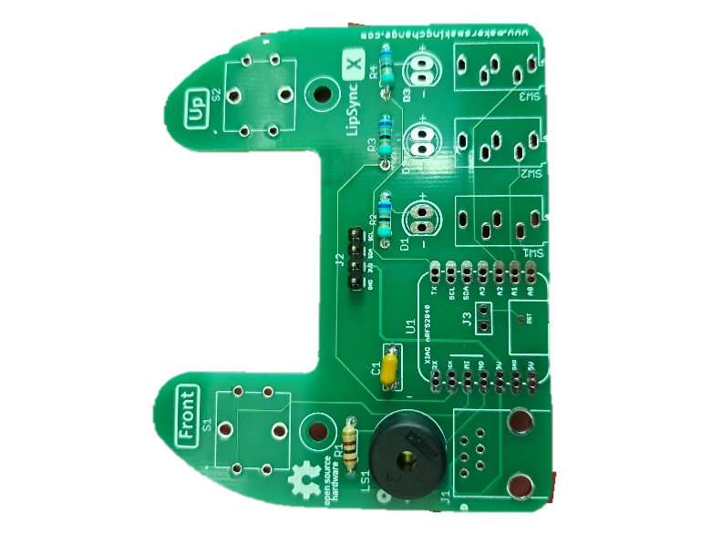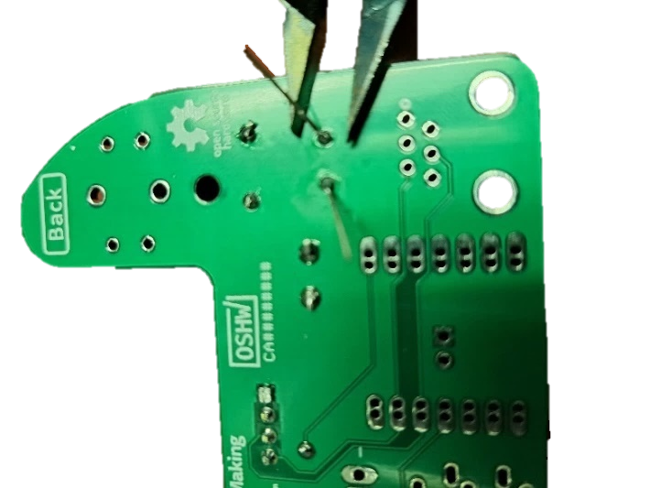

#### Step A-06: Insert, solder, and trim switches.

Insert the two tactile switches (A5) into the positions labeled S1 and S2. Once soldered in place, trim any excess from leads of the switches.

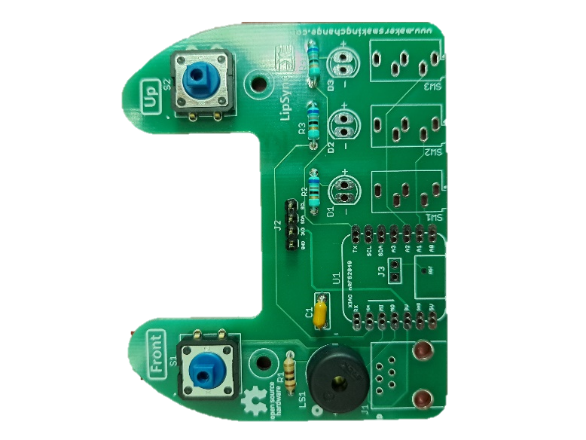

#### Step A-07: Insert and solder SparkFun QWIIC Adapter.

Place the SparkFun QWIIC Adapter (A8) on the 4-pin male header (A7) that was attached to J2 in step A-04. Ensure the pin labels on the adapter matches the pin labels on the Hub PCB. Solder the four pins on the adapter.

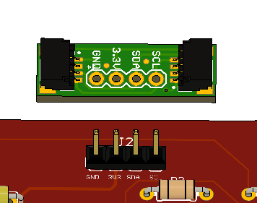

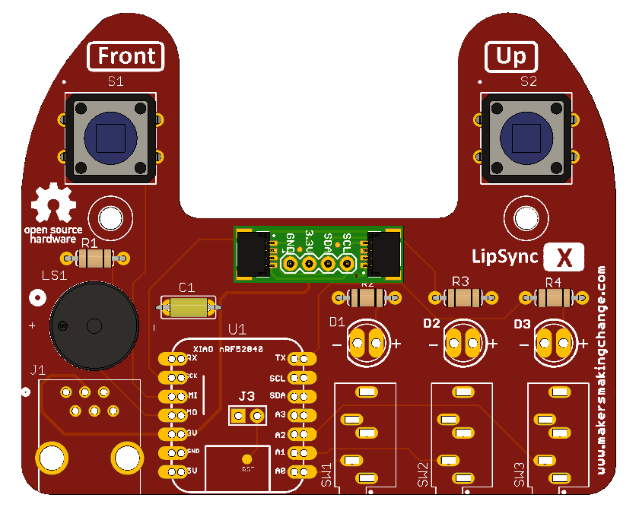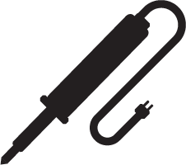

#### Step A-08: Insert and solder switch jacks.

Insert the switch jacks (A9) into the positions labeled SW1, SW2, and SW3. Solder one pin on each switch jack, then check the alignment. If the alignment needs to be changed, reheat the solder joint until the solder melts, then reposition the jack. Once the jacks are positioned properly, solder the remaining pins.

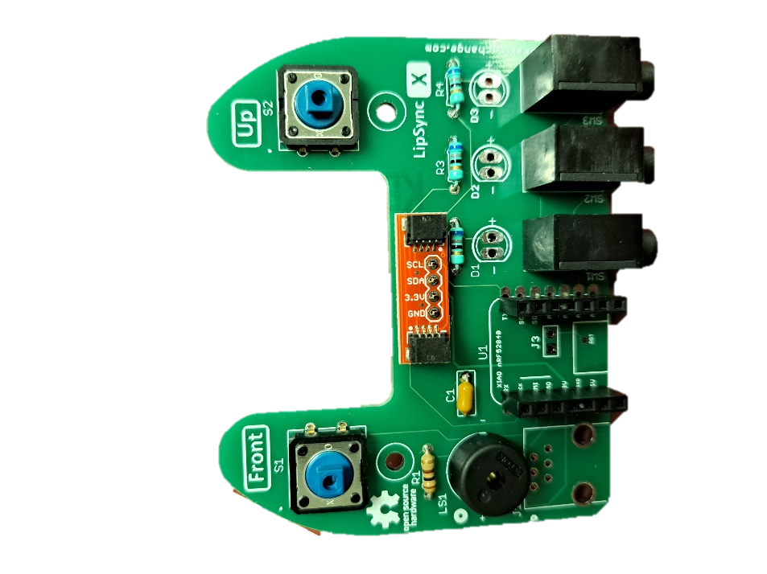

#### Step A-09: Solder male headers onto microcontroller.

Insert the short side of the male headers (A12) into the SeeedStudio Xiao nrf52840 microcontroller (A11) from the bottom of the board. To align the male headers and keep them straight when soldering, take the 7-position female headers (A13), and insert the male headers into the female headers across the microcontroller (as shown in the picture on the left).

Alternatively, a solderless breadboard can be used, plug the unsoldered microcontroller and headers into the protoboard and the protoboard will hold the headers in the proper alignment.

Solder the male headers onto the microcontroller, making sure not to connect adjacent pads together with solder. Once soldered, remove the 7-pin female headers from the male headers.

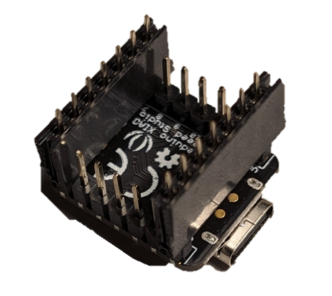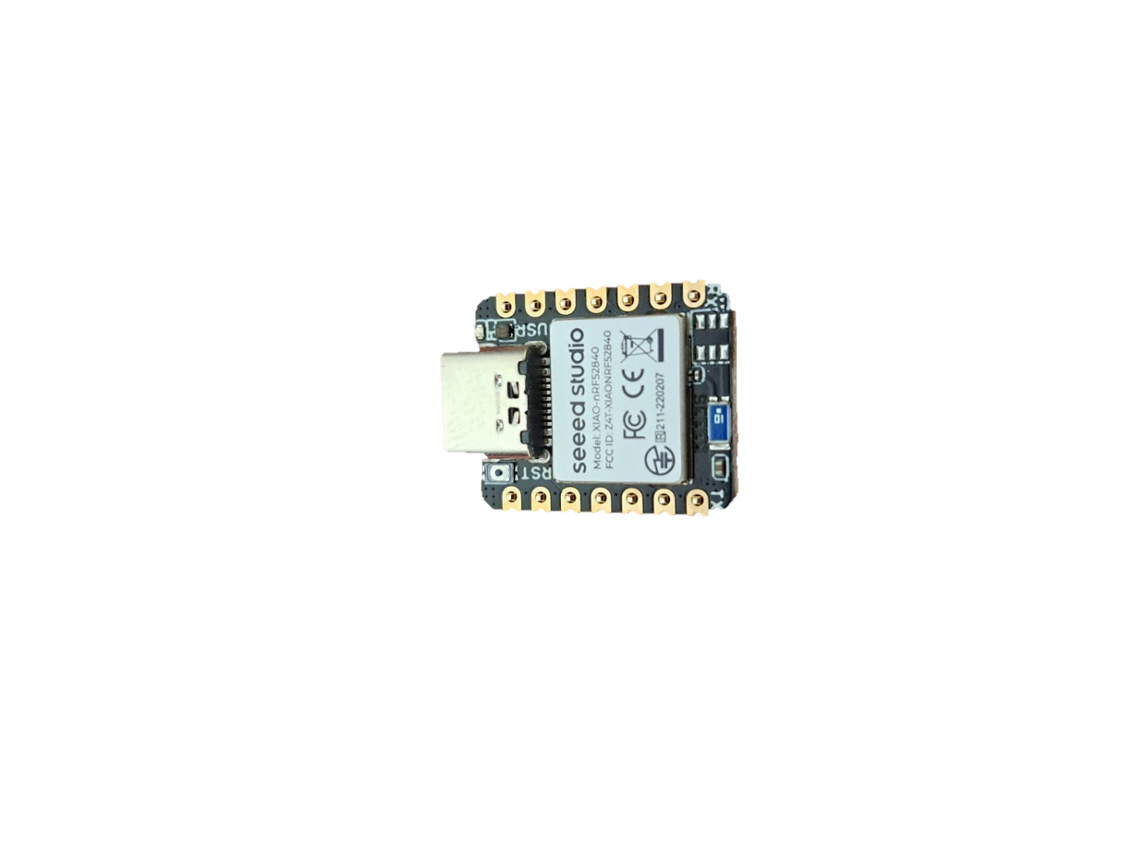

#### Step A-10: Solder female microcontroller header into PCB.

Insert microcontroller with male headers into the female headers (A13). Insert the female headers into PCB. Solder 1 pin on each header. Check alignment and adjust if necessary. If you need to adjust the alignment, heat the single soldered pin until the solder melts again and adjust the position of the row of headers. Once aligned, solder remaining headers.

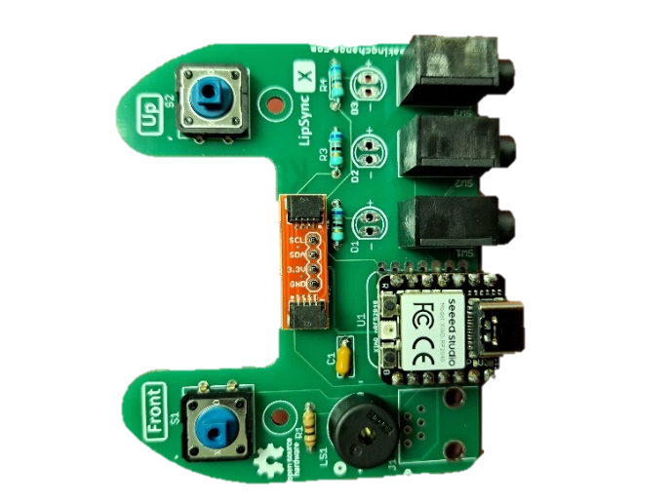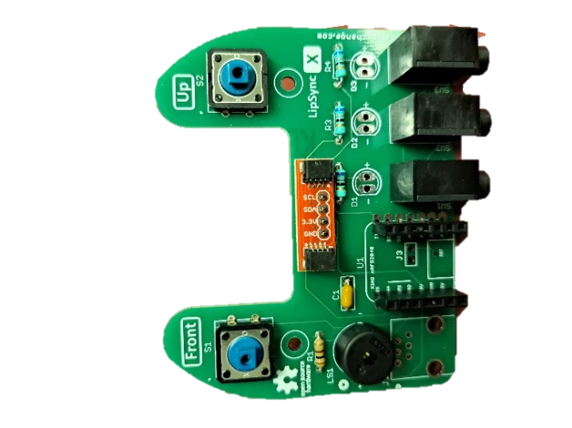

#### Step A-11: Insert and solder the RJ11 jack.

Insert the RJ11 jack (A10) into the position labeled J1 on the PCB. Solder the six pins into place.

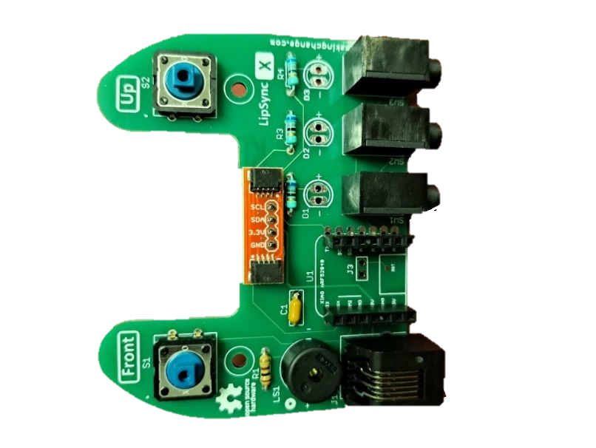

#### Step A-12: Insert, solder, and trim LEDS.

Insert the three LEDs (A14) into the 3D printed LED Spacer(A15). Ensure the shorter lead of the LED (the negative lead) is on the same side as the flat edge of the LED Spacer. The LED will also have a flat edge matching the flat edge on the spacer.

With the LEDs inserted into the spacer, insert the LEDs into the matching holes in the PCB. The flat side of the LED spacer should be on the left with the rounded side on the right, when looking at the PCB from the front. Solder the LEDs in place and trim the excess from the leads.

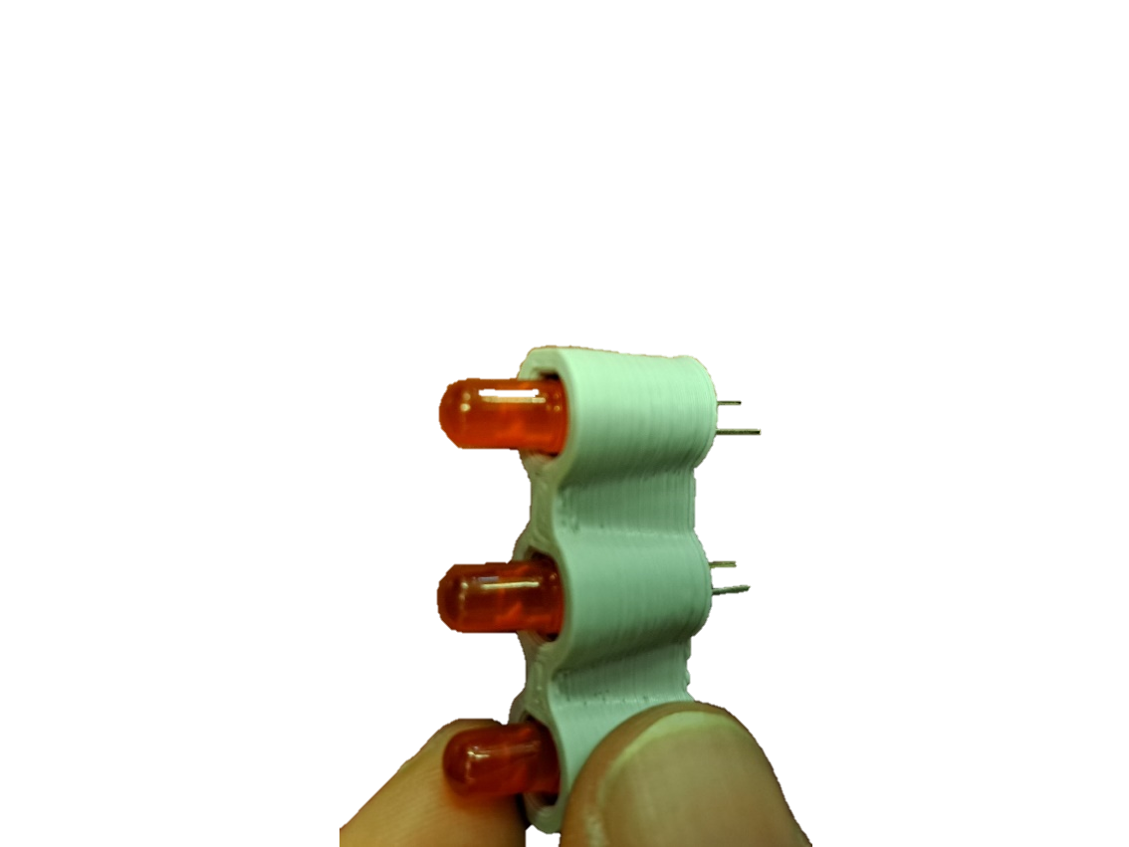 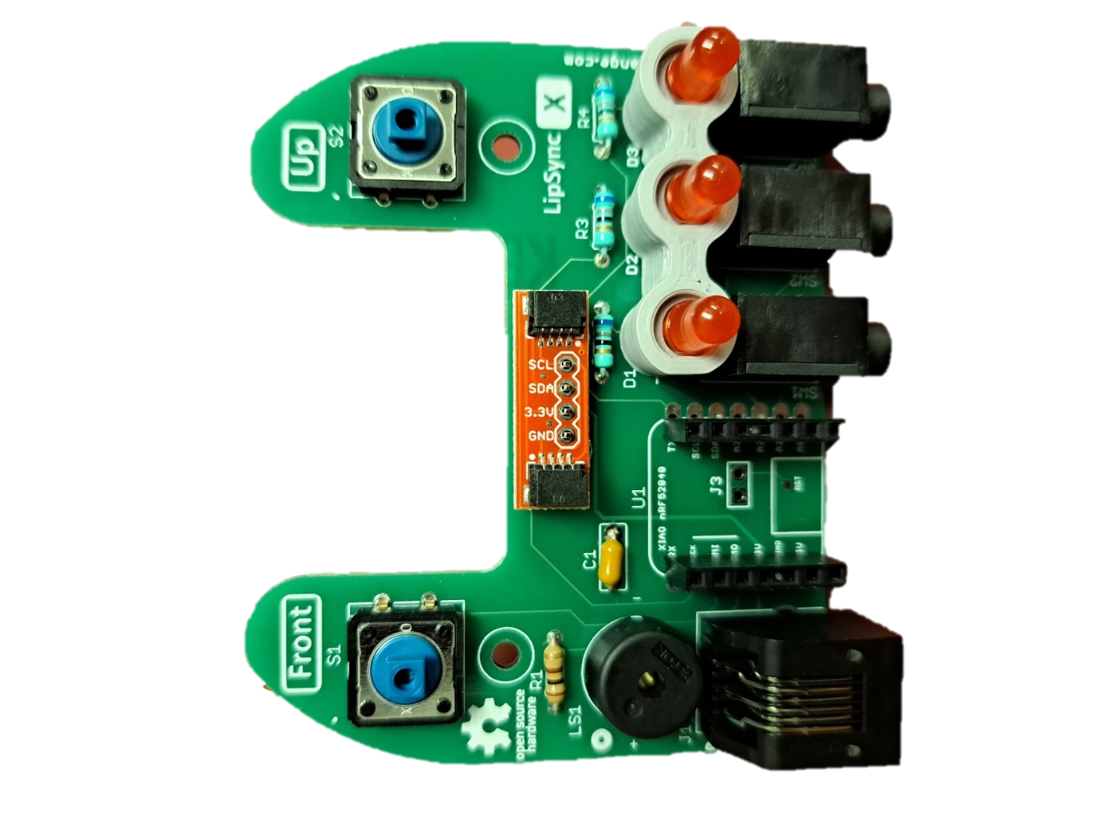

#### Part A Complete

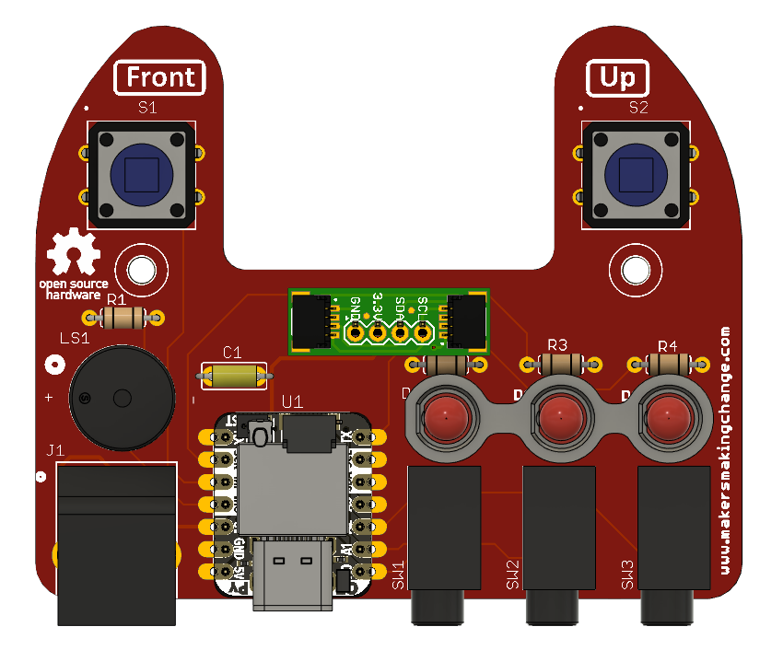

## Part B: Hub Enclosure Assembly

### Part B: Components

|  |  |  |  |  |  |  |  |  |
| --- | --- | --- | --- | --- | --- | --- | --- | --- |
| **B1** | Populated LipSync 4 Hub PCB | QTY 1 | **B2** | STEMMA QT Cable – 100 mm | QTY 1 | **B3** | OLED Display | QTY 1 |
| Populated LipSync circuit board | | | A 100 mm stemma cable | | | A LED display breakout board | | |
| **B4** | LipSync Hub Enclosure Top | QTY 1 | **B5** | LipSync Next Button Pusher | QTY 1 | **B6** | LipSync Select Button Pusher | QTY 1 |
| LipSync Hub top enclosure 3D print | | | A lipsync next button pusher | | | A Lipsync select button pusher | | |
| **B7** | LipSync Hub Enclosure Bottom | QTY 1 | **B8** | Screw, #4, 3/8” Length | QTY 5 | **B9** | M2.5 Machine Screw, 8 mm | QTY 4 |
| Hub bottom enclosure 3D print | | | #4 Sheet metal screw, 3/8" length | | | A close-up of a M2.5 bolt | | |
| **B10** | M2.5 Nut | QTY 4 | **B12** | T-Nut | QTY 1 | **B13** | Light Pipe | QTY 1 |
| A close up of a M2.5 nut | | | A close up of the T-nut | | | A close up of the light pipe | | |

### Part B: Tools

* Phillips Head Screwdriver

### Part B: Personal Protective Equipment (PPE)

* Safety glasses

### Part B: Assembling Hub Enclosure Steps

#### Step B-01: Connect Display to LipSync 4 Hub Enclosure Top

Peel off the protective film on the Display (B3) and connect it to the Hub Enclosure Top (B4) using four nylon M2.5 machine screws (B9) and four nylon M2.5 hex nuts (B10). Do not overtighten.

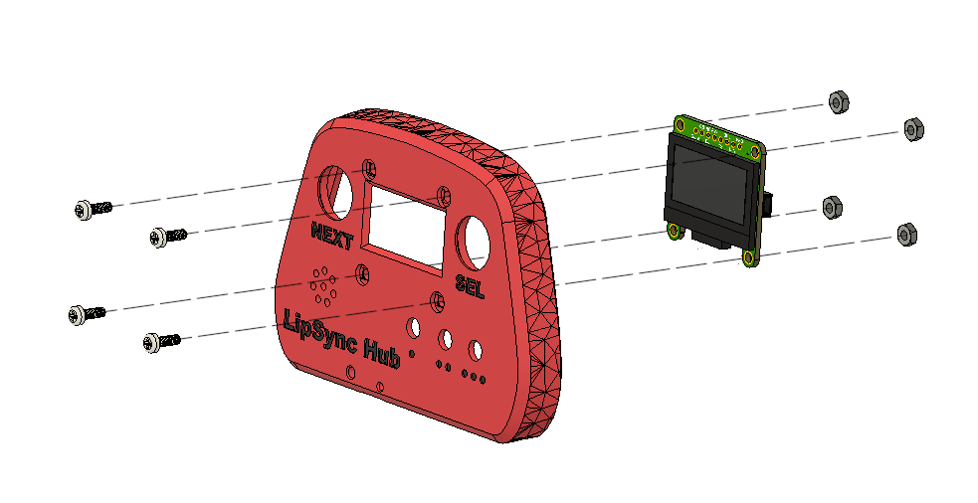

#### Step B-02: Insert the Light Pipe

From the front side, insert the **light pipe** (B13) into the Hub Enclosure Top.

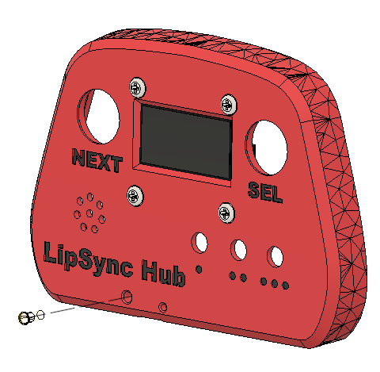

#### Step B-03: Connect STEMMA / QWIIC Cable to Display

Flip the Hub Top over so the Display is facing down. Connect the 100 mm STEMMA/QWIIC cable (B2) to the port on the right-hand side of the Display as shown. Ensure the holes for the pins in the cable line up with the pins in the port on the PCB. Do not connect the second end of the STEMMA/QWIIC cable to the second port on the screen.

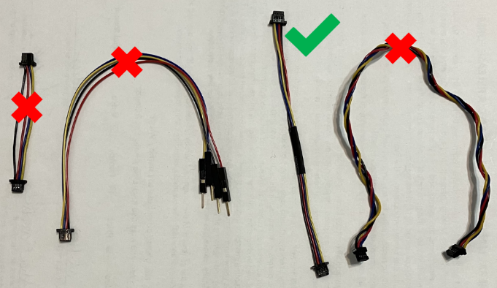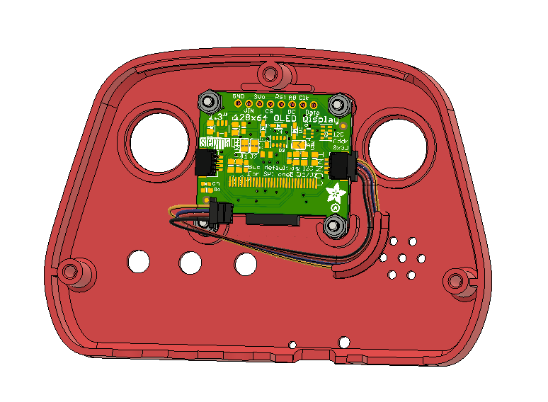

#### Step B-04: Insert the Tee Nut into the Hub Bottom

Insert the tee nut (B12) into the slots inside the Hub Bottom. A ¼” machine screw or hex bolt can be used to tighten the Tee Nut into place. The nut should sit flush with the enclosure.

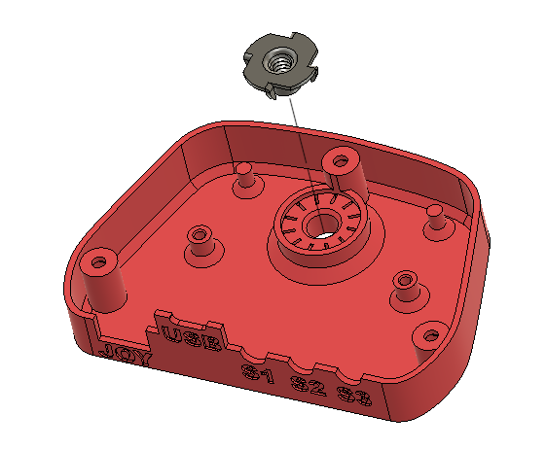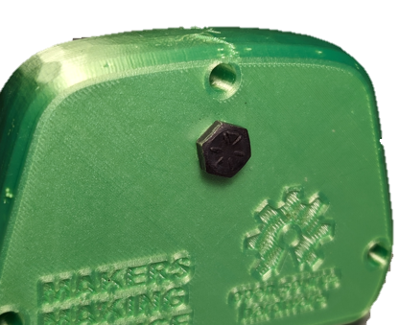

#### Step B-05: Secure LipSync Hub PCB into Hub Bottom

Use two #4 sheet metal screws (B8) to secure the PCB (A1) into the Hub Bottom.

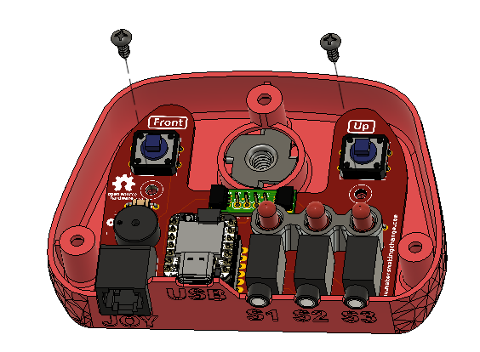

#### Step B-06: Connect the STEMMA / QWIIC Cable to the QWIIC Adapter on the PCB

Connect the 100 mm STEMMA/QWIIC cable from the display to the QWIIC adapter on the PCB. Again, ensure the holes for the pins in the cable line up with the pins in the port on the PCB.

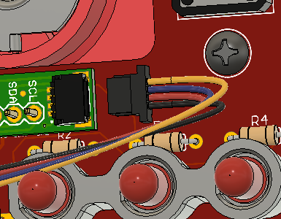 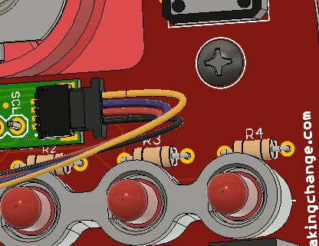

#### Step B-07: Place the Button Pushers on top of the Buttons

Position the Select Button (B6) and the Next Button (B5) on top of the Buttons on the PCB. The Next Button goes on the left button and has a target shape on the front. The Select Button goes on the right button and has a ring printed on the front.

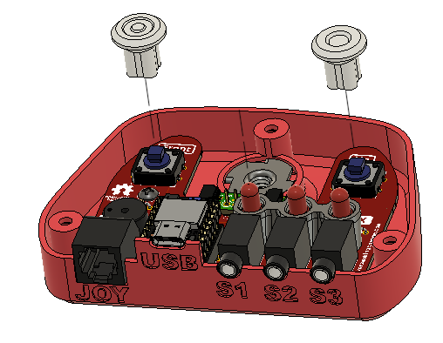

#### Step B-08: Position the Hub Top on to the Hub Bottom

Position the Hub Top onto the Hub Bottom, making sure to align the Button Pushers and their LEDs with the corresponding hole.

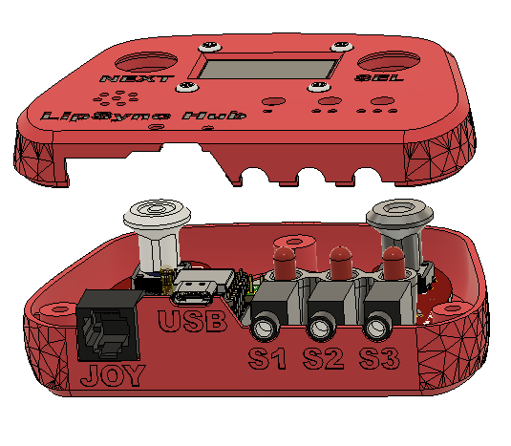

#### Step B-09: Secure the Hub Top and Hub Bottom

Carefully turn the Hub over. Use a #4 sheet metal screw(B8) in each of the three holes to secure the two parts together.

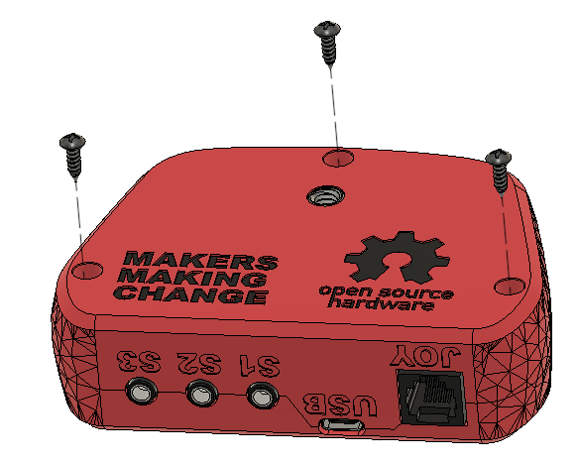

#### Part B Complete

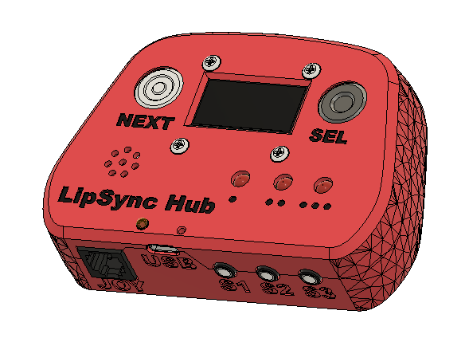

## Part C: Mouthpiece Assembly

### Part C: Components

|  |  |  |  |  |  |  |  |  |  |
| --- | --- | --- | --- | --- | --- | --- | --- | --- | --- |
| **C1** | Syringe FIlter | | QTY 6 | **C2** | Dental Straw | QTY 2 | **C3** | 2 mm ID 4 mm OD Tube | QTY 6 cm |
| A close up of the syringe filter | | | | A close up of the dental straw | | | Silicone tubing, 2 mm inner diameter and 4 mm outer diameter | | |
| **C4** | Silicone Straw | QTY 2 | | **C5** | Cable Tie | QTY 6 |
| A section of silicone straw | | | | A close up of a zip tie | | |

### Part C: Tools

* Wire Cutters
* Silicone Sealant

### Part C: Personal Protective Equipment (PPE)

* Safety glasses

### Part C: Assembling the Mouthpiece Steps

The rulers shown in this section are to-scale so can be used to measure the required lengths of each part.

#### Step C-01: Cut Dental Straw to length

Using wire trimmers (not scissors), cut the dental straws (C2) to six, 2.5 cm lengths, excluding the blue tip on the end as it can come off and become a choking hazard. The same straw can be used to make several mouthpieces.

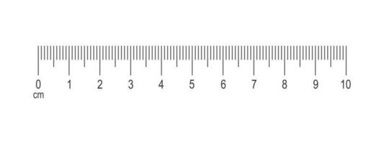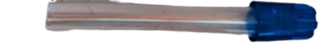

#### Step C-02: Cut the Silicone Straw to length

Cut the silicone straw (C4) to six, 5cm lengths.

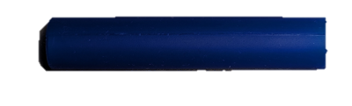

#### Step C-03: Cut the tubing to length

Take the tubing (C3) and cut it to six, 1 cm lengths.

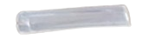

#### Step C-04: Slide the Tubing on the Filter

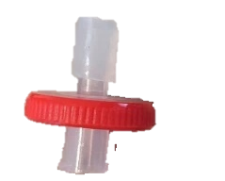Slide the cut length of tubing over the slip connection on the Filter (C1). Leave a gap of several millimeters between the end of the tube and the body of the filter so it has more room to slide down when adding the filter. Repeat this step 6 times for each filter.

#### Step C-05: Attach the Dental Straw to Filter

Carefully work the dental straw over the filter and tube assembly. Push it as far down as possible using a twisting motion, until the tube from the previous step starts to squish against the filter. Repeat this step 6 times for each assembly.

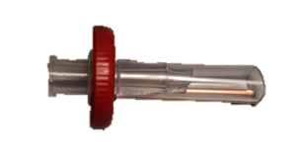

#### Step C-06: Seal mouthpiece with silicone

A tube of food grade silicone sealant is used to make the mouthpiece entirely airtight and add strength to the connection. The silicone is applied as any caulking would be around the joint where the dental straw meets the filter disk. Repeat this step 6 times for each assembly.

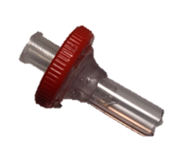

#### Step C-07: Attach the Silicone Straw

Press the silicone straw over the dental straw, setting it into the sealant at the base of the filter. More silicone sealant can be used around the edge of the silicone straw if there isn’t enough sealant from the previous step to seat the straw in. Repeat this step 6 times for each assembly.

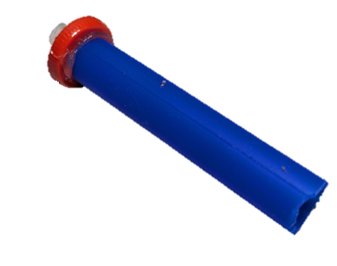

#### Step C-08: Secure the straw with a Cable Tie

If the silicone straw used is too large to snuggly fit over the dental straw, a cable tie (C5) can be used to secure it. Tighten the cable tie roughly a centimeter from the filter and cut the cable tie flush so there are no sharp edges protruding. Repeat this step 6 times for each assembly.

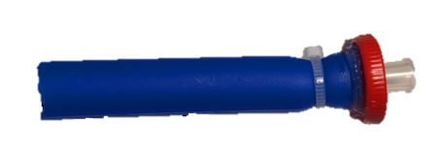

#### Part C Complete

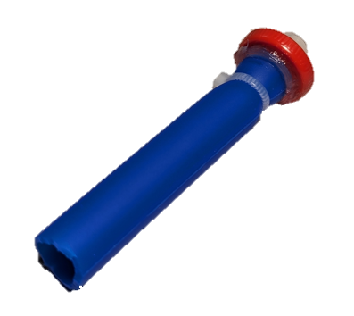

## Part D: Joystick Gimbal Assembly

### Part D: Components

|  |  |  |  |  |  |  |  |  |
| --- | --- | --- | --- | --- | --- | --- | --- | --- |
| **D1** | Inner_Gimbal_1 | QTY 1 | **D2** | Inner_Gimbal_2 | QTY 1 | **D3** | Outer_Gimbal_1 | QTY 1 |
| A close up of the inner gimbal 1 print | | | A close up of the inner gimbal 2 print | | | A close up of the outer gimbal 1 print | | |
| **D4** | Outer_Gimbal_2 | QTY 1 | **D5** | Gimbal Shield | QTY 1 | **D6** | Sled | QTY 1 |
| A close up of the outer gimbal 2 print | | | A close up of the gimbal shield print | | | A close up of the sled | | |
| **D7** | Magnet Retainment | QTY 2 | **D8** | LPS33 STEMMA QT Board | QTY 1 | **D9** | TLV493D STEMMA QT Board | QTY 1 |
| A close up of the magnetic retainment pin | | | A close up of the pressure sensor | | | A close up of the magnetic sensor | | |
| **D10** | Male Luer Connector | QTY 1 | **D11** | 2mm ID 4mm OD Tube | QTY 1 | **D12** | Cable, STEMMA, 200 mm | QTY 1 |
| A close up of the male Luer connector | | | Close up of a 2mm ID 4mm OD silicone tube. | | | A close-up of a 200mm stemma cable | | |
| **D13** | Magnet | QTY 3 | **D14** | Bearings | QTY 4 | **D15** | Cable, STEMMA, 50 mm | QTY 1 |
| A close up photo of the magnet | | | A close-up of a metal bearing | | | A close-up of a 50mm stemma cable | | |
| **D16** | M2.5 Nut | QTY 2 | **D17** | M2.5 Machine Screw, 8 mm | QTY 2 |
| A close up of a M2.5 nut | | | A M2.5 Bolt | | |

### Part D: Tools

* Phillips Head Screwdriver
* Scissors
* Flush cutters
* OPTIONAL: File or coarse sandpaper

### Part D: Personal Protective Equipment (PPE)

* Safety glasses

### Part D: Joystick Gimbal Assembly Steps

The rulers shown in this section are to-scale so can be used to measure the required lengths of each part.

#### Step D-01: Cut the Tubing to length

Cut a 1.5 cm length of tubing (D11).

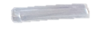

#### Step D-02: Connect the tubing to the Luer connector

Push the tubing over the barb on the Luer connector(D10), until about 2 mm is past the barb.

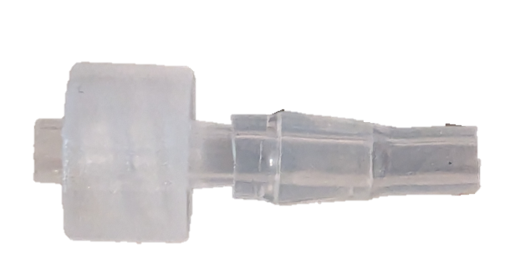

#### Step D-03: Connect the tubing to the Pressure Sensor

Press the other end of the tubing over the circular port on the LPS33 Pressure Sensor (D8).

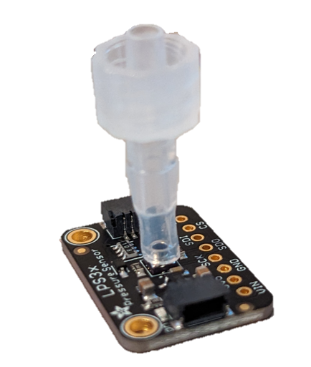

#### Step D-04: Attach the Tubing Assembly to the Joystick

Take the Inner Gimbal 1 3D print (D1) and press the Luer connector assembly into the slot at the front by the threads. The Luer connector must be inserted so there is a flat edge along the top and bottom, as seen in the photo on the right. The tube length should be such that the pressure sensor fits into the first slot behind the bearing shafts. When viewing the assembly from the front, the text on the sensor should be on the side facing the bearing shafts.

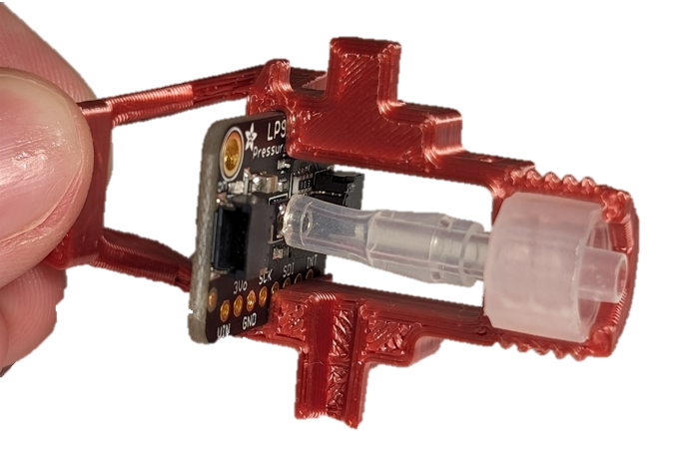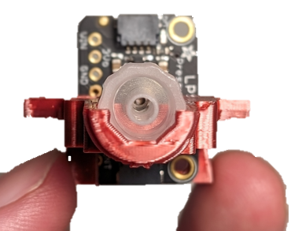

#### Step D-05: Attach the Magnetic Sensor

Slide the Magnetic Sensor (D9) into the Inner Gimbal 1 so that it is arranged back-to-back with the pressure sensor with the text facing to the left. The two sensors should have the same up/down orientation, with the text at the top, and the breakout pins at the bottom.

Secure the two sensors in place by inserting a nylon M2.5 machine screws (D17) into the left-most hole in the Pressure Sensor board, through the hole in the Inner Gimbal and through the hole in the Magnetic Sensor. Loosely attach the nylon hex nut (D16), but do not fully tighten.

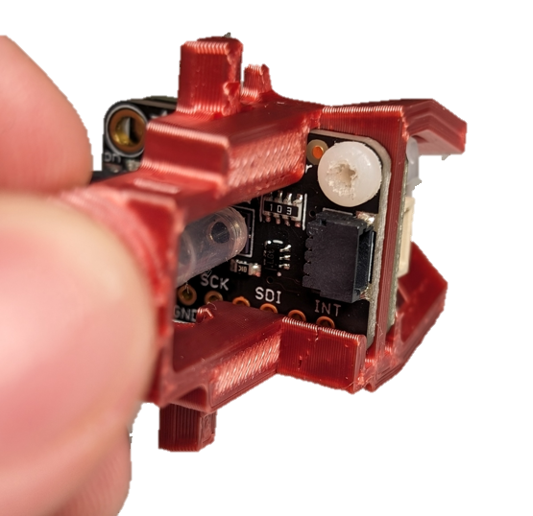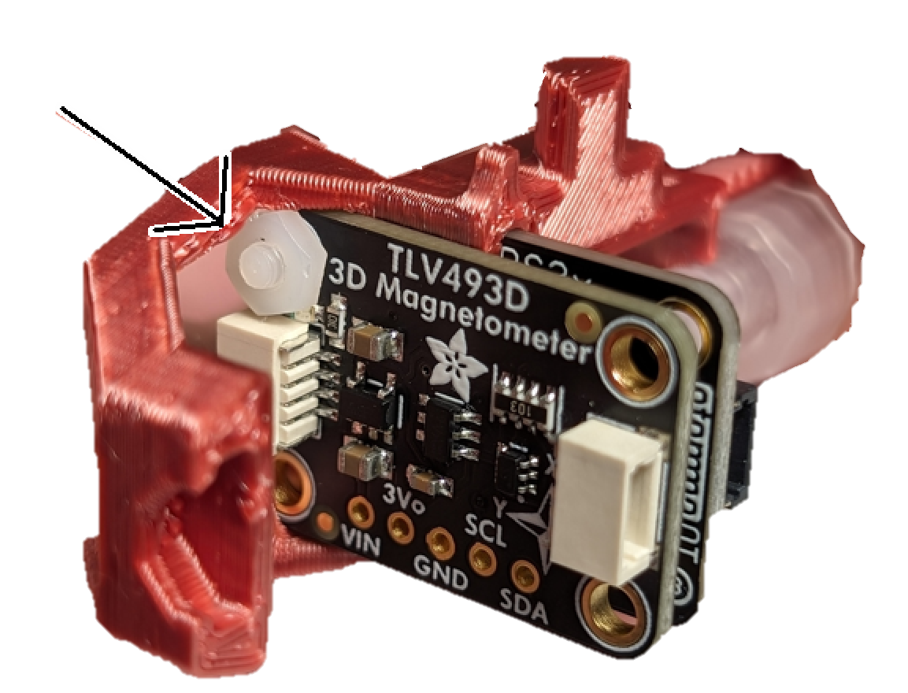

#### Step D-07: Attach the STEMMA Cable

Take the 200 mm STEMMA cable (D12) and attach it to the magnetic sensor on the side that has the bolt attached. Route it above the pressure tube as seen in the below photo.

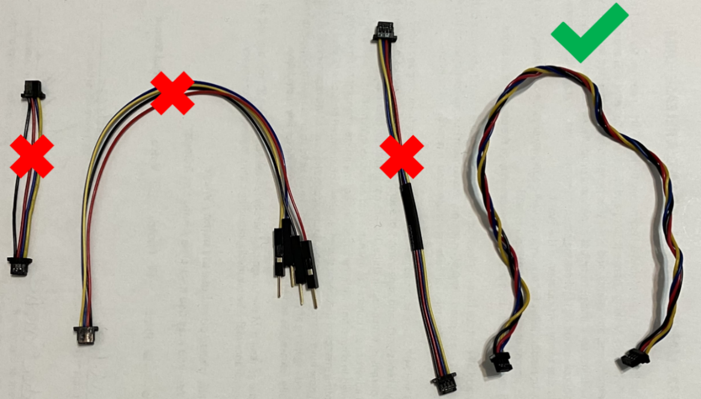

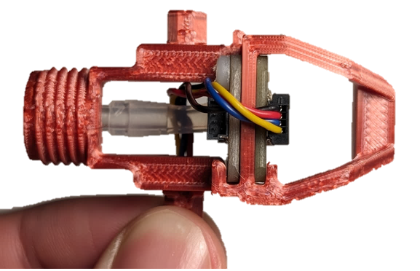

#### Step D-08: Route the cable out of the Inner Gimbal

Route the cable over the air path, and through the slot in the bearing shaft as seen in the photo.

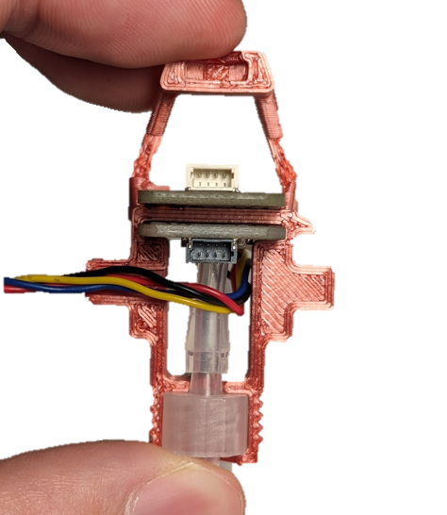

#### Step D-09: Insert the Moving Centering Magnet

Gently press a magnet (D13) into the cradle in the very back of the assembly. The orientation of the magnet does not matter in this step.

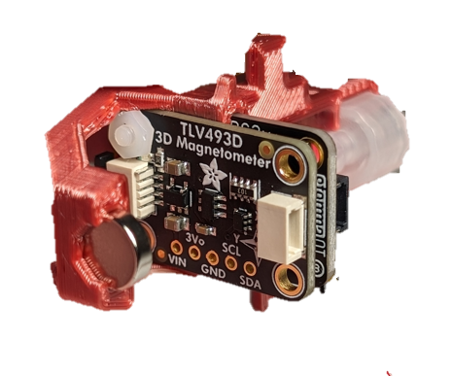

#### Step D-10: Attach the other half of the Inner Gimbal

Slide Inner Gimbal 2 (D2) over the assembly. Make sure that the Luer connector, sensor boards, and magnet line up with their corresponding slots.

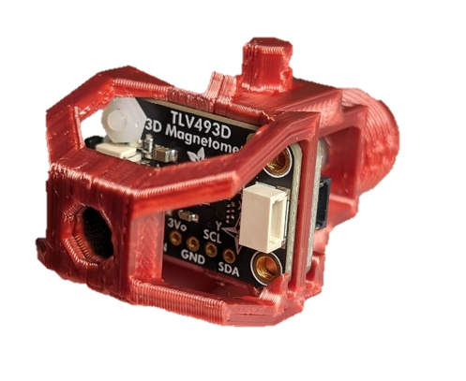

#### Step D-11: Attach the second Machine Screw and Nut

Add the second nylon nut (D16) and bolt (D17) in the same orientation as the first, and fully tighten them both.

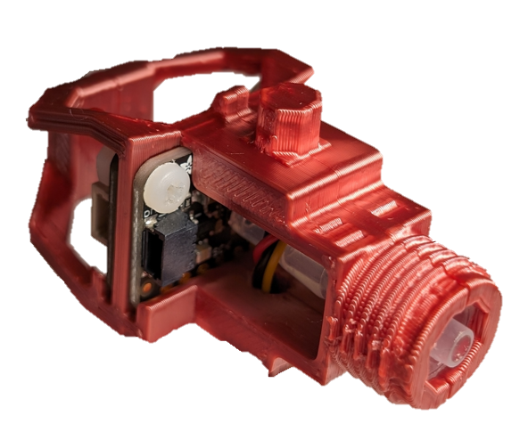

#### Step D-12: Trim the edges of the STEMMA Cable Connector

Take the free end of the 200 mm STEMMA cable that exits the Inner Gimbal Assembly and trim the two flanges on the end of the connector flush.

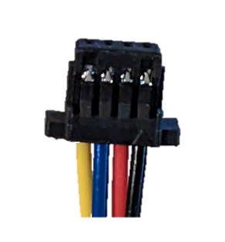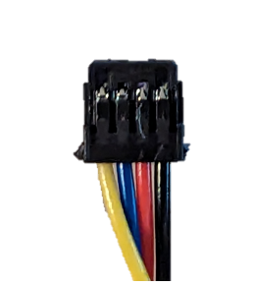

#### Step D-13: Attach Bearings to the Inner Gimbal

Press one Bearings (D14) over both bearing shafts on the inner gimbal. For the shaft with the cable coming out, pass the cable through the inside of the bearing before placing it on the shaft.

Note: If you are having trouble getting the bearings to fit on the shafts, first try sanding down the corners of the octagonal shafts. If they still do not fit, use pliers to gently press them onto the shaft.

**WARNING: Do not hit the bearings with a hammer or mallet. Do not hit the gimbal on the table or any other hard surface.**

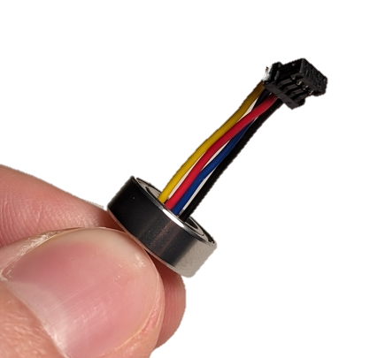 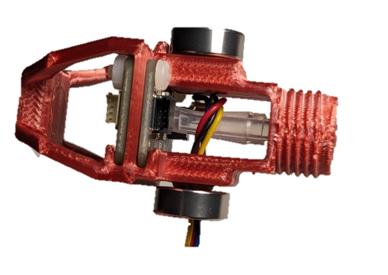

#### Step D-14: Connect the Pressure Sensor and Magnetic Sensor

The 50 mm STEMMA Cable (D15) is used to connect the Pressure Sensor to the Magnetic Sensor. First, connect one end of the STEMMA Cable to the open connector on the Pressure Sensor Board. Next, wrap the cable around the post of the Inner Gimbal. Finally, attach the other end of the STEMMA Cable to the connector on the Magnetic Sensor Board on the same side as the Pressure Sensor.

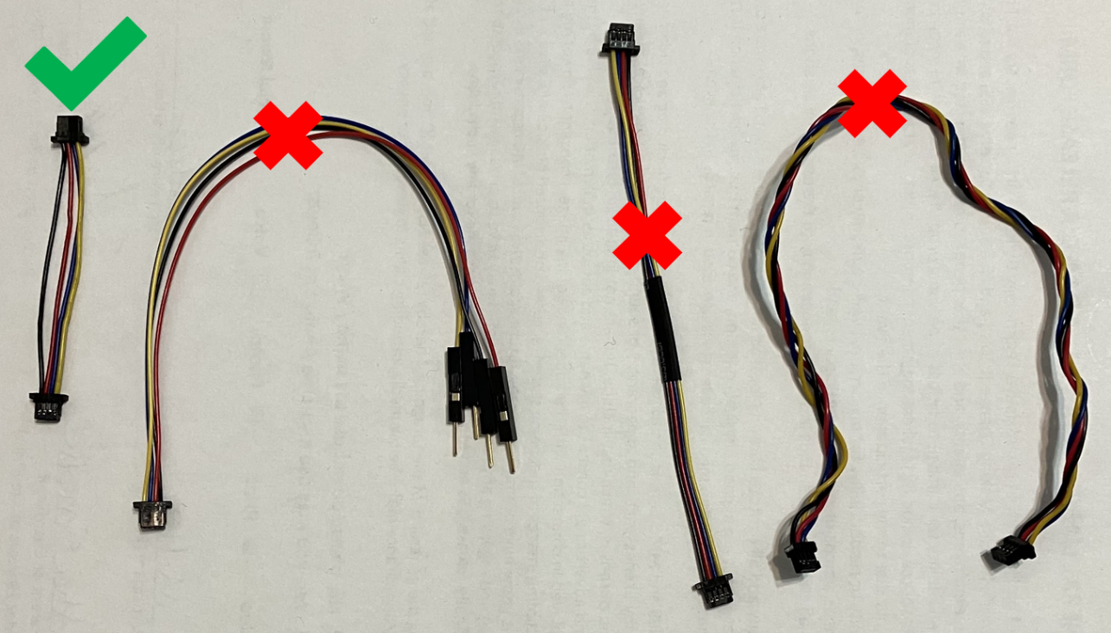

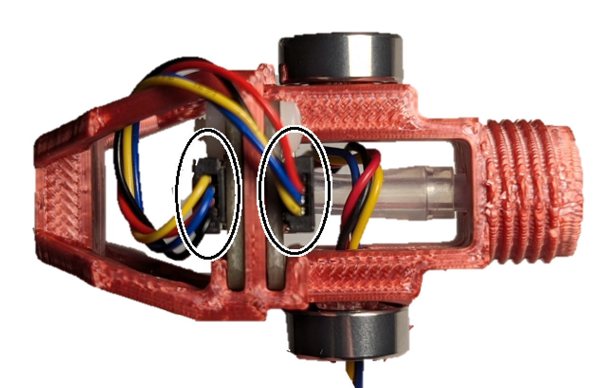

#### Step D-15: Assemble the Outer Gimbal on to the Inner Gimbal Assembly

Take Outer Gimbal 1 (D3, marked with “I”) and coming from the magnet side towards the Luer connector side, pass it over the Inner Gimbal Assembly. One side of the bearing cover will be hollow, and one will be covered. Align the outer gimbal so that the hollow side is on the same bearing that the STEMMA cable is passing through.

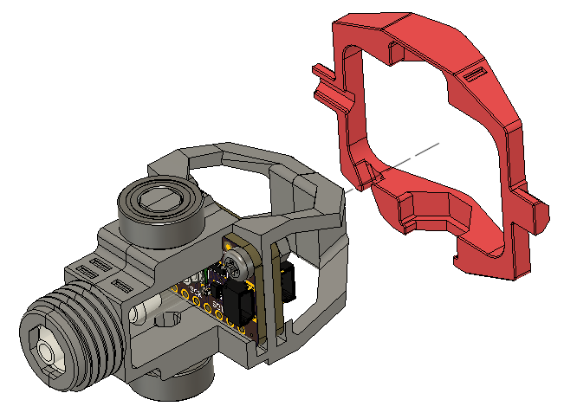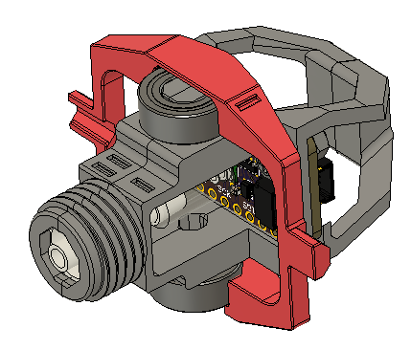

#### Step D-16: Route cable through the Outer Gimbal

Pass the cable through the slot on the outer gimbal, and then out through the hollow bearing shaft. A pair of tweezers can be used to push the wires into the slot.

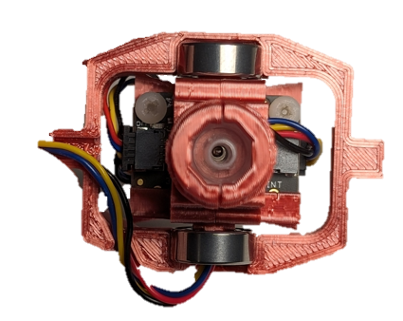

#### Step D-17: Connect the second half of the Outer Gimbal

Press the front half of the Outer Gimbal (Outer Gimbal 2, D4, marked with “II”) over the front Luer section and towards the rear, ensuring that the cable is properly connected to the correct cable management slots.

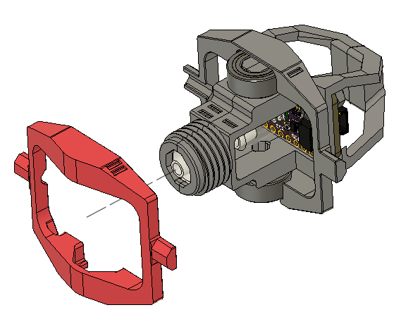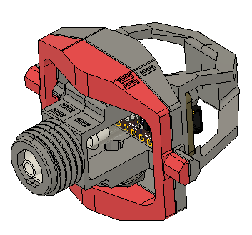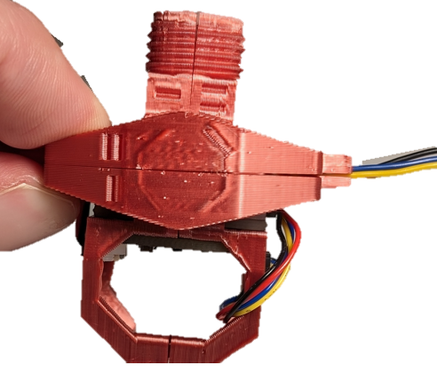

#### Step D-18 Secure Outer Bearing to Gimbal

Secure the two halves of the Outer Gimbal using two bearings (D14). Gently pull on the cable after the bearings are attached to remove any slack.

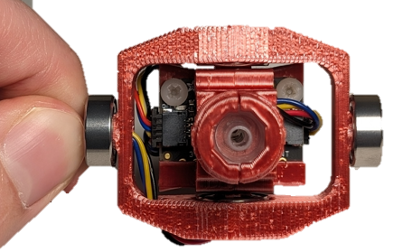

#### Step D-17: Screw on the Gimbal Shield

Take the Gimbal Shield (D5) and screw it onto the threads at the front of the gimbal until it hits the gimbal hard stop at the back.

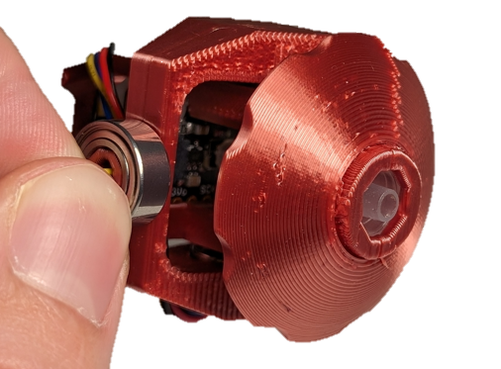

#### Step D-19: Insert Magnets into Sled

Take the Sled (D6), and two Magnets (D13). Stick the two magnets to either side of the gimbal magnet from the previous steps, and make note of their orientation. While keeping them in the same orientation, gently but firmly push them into the two highlighted slots in the sled, until they are firmly seated at the bottom of the slots. It is very important to seat these magnets at the bottom of the slots.

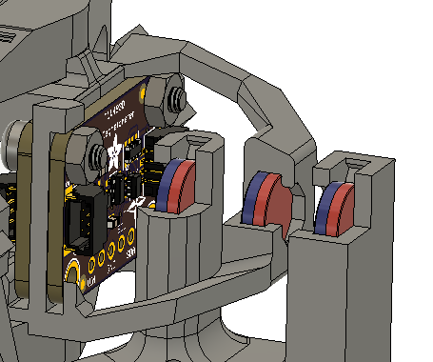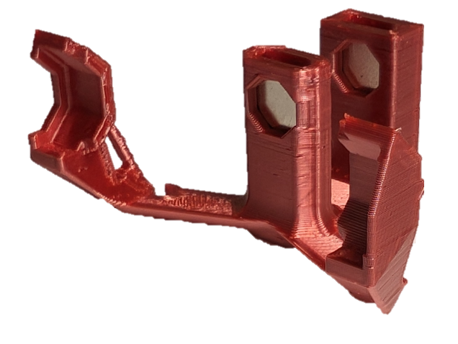

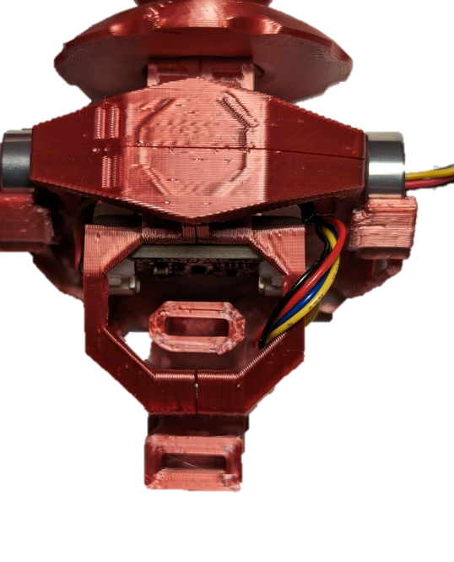

#### Step D-20: Secure the Magnets into the Sled

With the magnets pushed down fully, push a Magnet Clip (D7) into each of the Sled slots to secure the magnets in place.

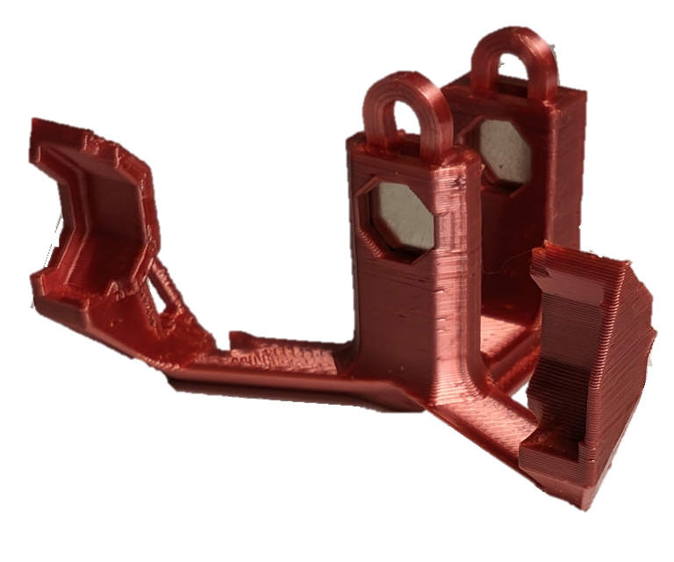

#### Step D-21: Place Gimbal Assembly in the Sled

Slot the Gimbal into the Sled. Slot the magnet in the back of the gimbal between the two towers on the sled, and then gently attach the arms to the bearings. One side of the sled has a cover over the bearing slot and one side has an open bearing slot. The side of the gimbal with the cables coming out of it lines up with the open bearing slot with no cover.

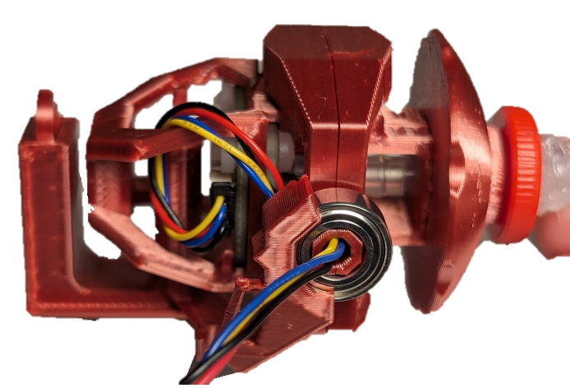 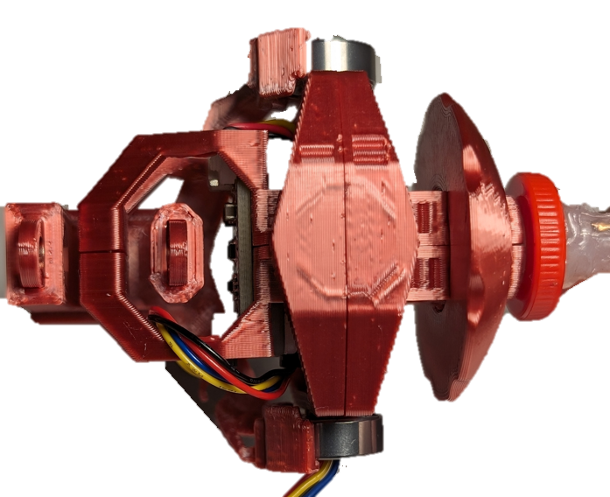

#### Step D-22: Route the STEMMA Cable through the Sled

Take the STEMMA Cable that is leaving the gimbal through the bearing, and thread it through slot on the sled, then clip it into the ¾ circle at the bottom of the sled, as seen in the below photos.

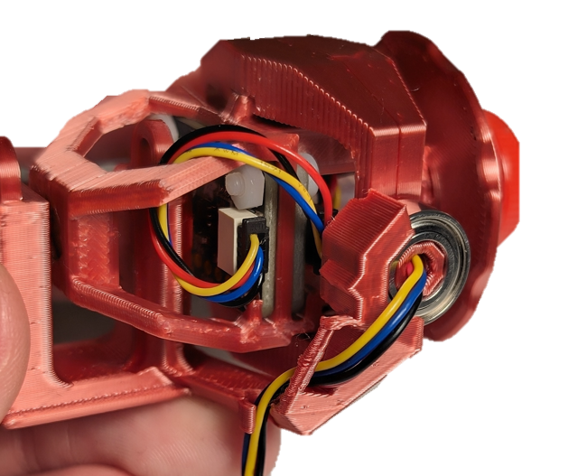 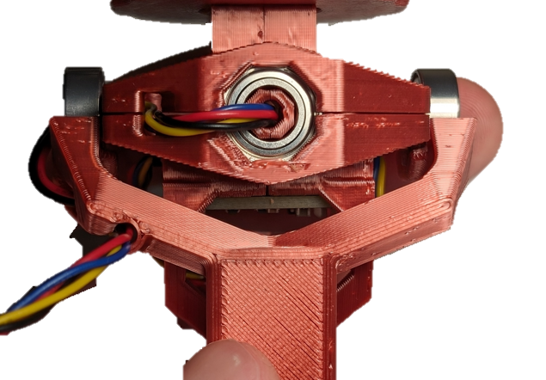

#### Part D Complete

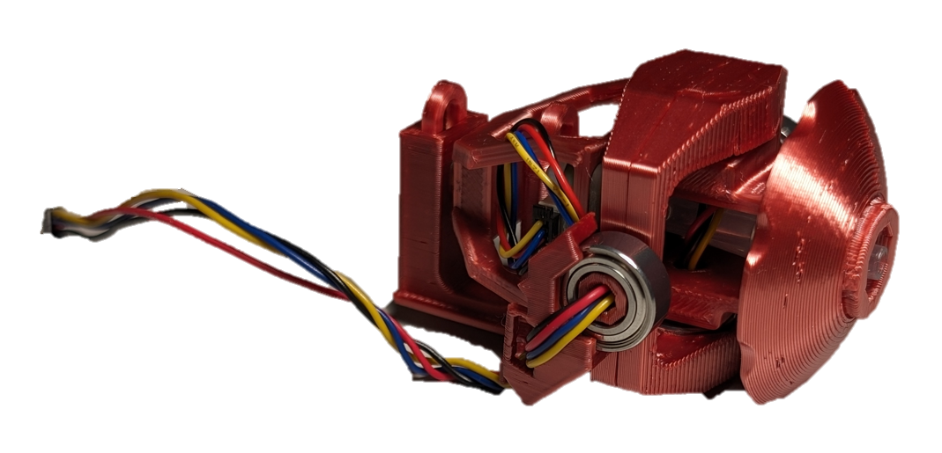

## Part E: Joystick Housing Assembly

### Part E: Components

|  |  |  |  |  |  |  |  |  |
| --- | --- | --- | --- | --- | --- | --- | --- | --- |
| **E1** | Front Cap | QTY 1 | **E2** | Joystick Housing | QTY 1 | **E3** | Inner Locking Ring | QTY 1 |
| A photo of the Front Cap 3D print | | | A photo of the Joystick Housing | | | A photo of the inner LipSync locking ring | | |
| **E4** | Outer Locking Ring | QTY 1 | **E5** | Rear Housing | QTY 1 | **E6** | LPS22 STEMMA QT Board | QTY 1 |
| A photo of the LipSync outer locking ring | | | A photo of the Rear housing for the LipSync joystick | | | A photo of a LPS22 pressure sensor breakout board | | |
| **E7** | Cable, STEMMA – DuPont, 150 mm | QTY 1 | **E8** | RJ11 Connector | QTY 1 | **E9** | RJ11 Breakout Board | QTY 1 |
| A photo of a stemma to dupont cable | | | A photo of an RJ11 jack | | | A close up of two connected RJ11 breakout boards | | |
| **E10** | M2.5 Bolt | QTY 1 | **E11** | M2.5 Nut | QTY 1 | **E12** | Light Pipe 0.250” | QTY 1 |
| A close up of an M2.5 bolt | | | A close up of a M2.5 nut | | | A photo of a light pipe | | |
| **E13** | Assembled Joystick Gimbal | QTY 1 | **E14** | ¼-20 T-nut | QTY 1 | **E15** | Screw, #4, 3/8” Length | QTY 3 |
| A photo of the assembled gimbal joystick | | | A photo of a T-Nut | | | A photo of a #4 3/8" metal screw on a white background. | | |

### Part E: Tools

* Phillips Head Screwdriver
* Soldering iron

### Part E: Personal Protective Equipment (PPE)

* Safety glasses

### Part E: Assembling Joystick Housing Steps

#### Step E-01: Insert the Light Pipe into the Joystick Housing

From the outside, press the light pipe (E12) into the Joystick Housing (E2). You can use a table or a hard surface to slowly press against to push the Light Pipe into place.

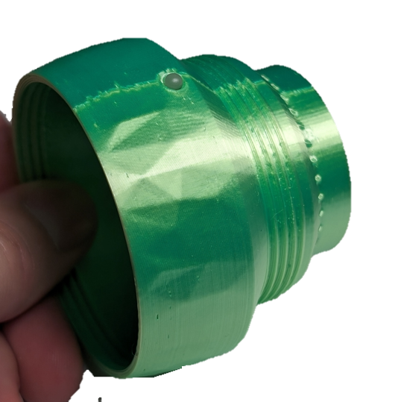

#### Step E-02: Solder the pads on the back of the LPS22 Pressure Sensor Board

Use solder to create a bridge between the solder pads on the back of the LPS22(E6) to change the default i2C address.

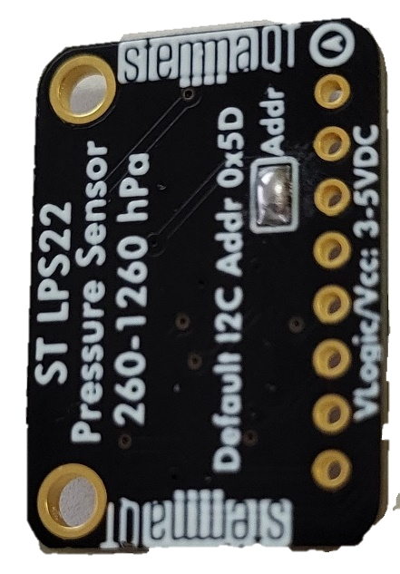

#### Step E-03: Connect the LPS22 Sensor Board to the gimbal STEMMA QT Cable

Connect the STEMMA QT cable coming from the gimbal (E13) to the LPS22 board. Ensure it is connected to the left port when viewing the board right-side up from the front. This is the port that has “on” printed above it.

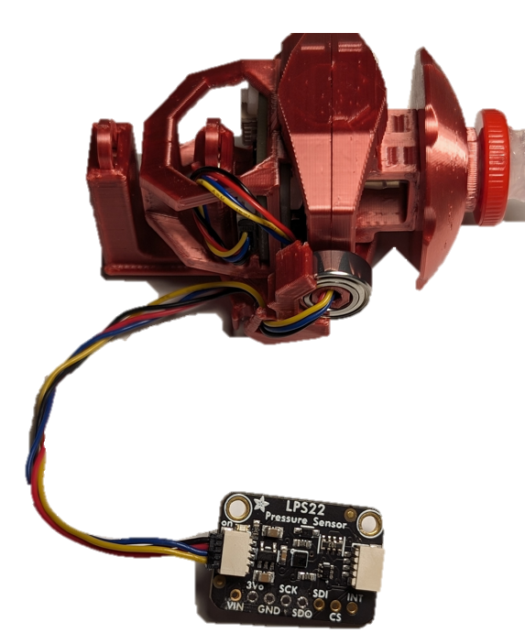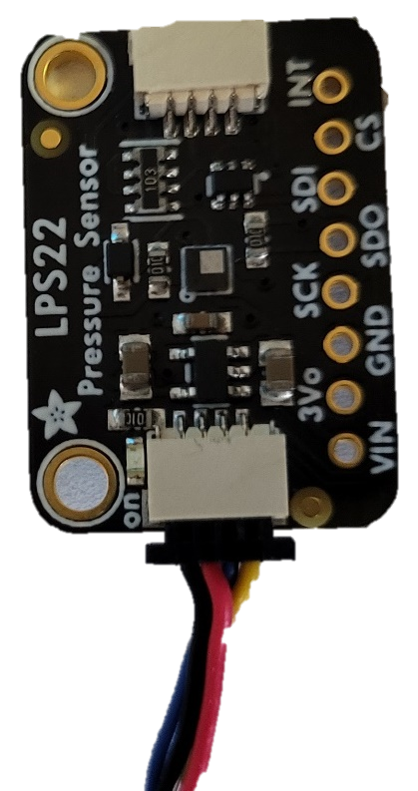

#### Step E-04: Insert the LPS22 board into the Joystick Housing

Entering through the larger opening (side with internal threads) of the joystick housing, snap (not slide) the LPS22 board into place directly below the light pipe so that the cable points toward the opening you just entered the part through. The components on the board should be facing towards the outer wall of the 3D print, not the hollow middle.

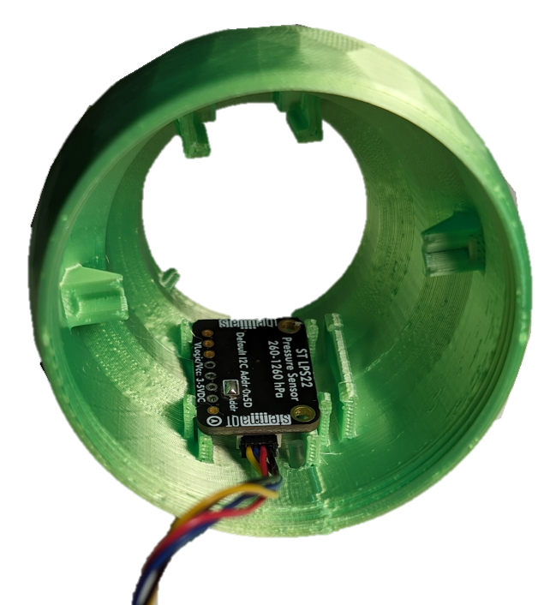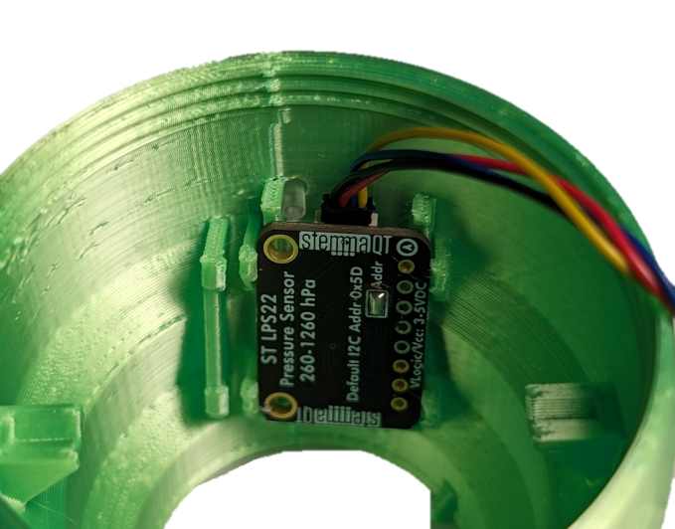

#### Step E-05: Route the Cable

Route the cable from where it connects to the LPS22 Sensor Board beside the board and towards the rear of the Joystick Housing. Insert the cable into the snap-fit beside the board.

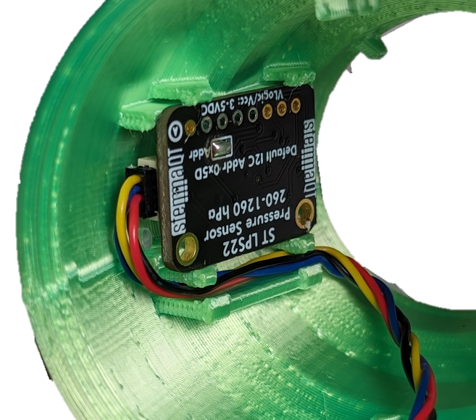

#### Step E-06: Insert the Gimbal Subassembly into the Joystick Housing

Entering through the same side as step 4, line up the sled so it will slot into the rails at the rear end of the joystick housing and slide it into place. Be careful to keep the STEMMA QT cable from getting pinched between printed parts.

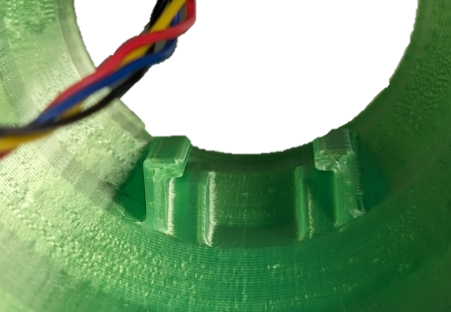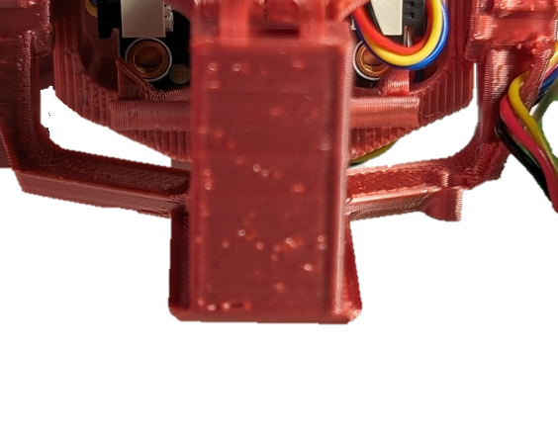

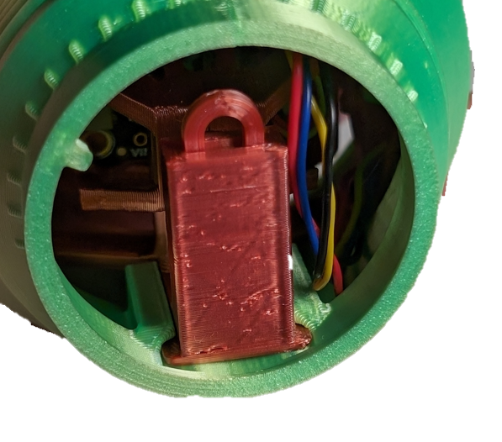

#### Step E-07: Screw on the Front Cap

Ensure the joystick is fully inserted and the cable is not interfering with any internal parts. Screw on the front cap (E1) by rotating clockwise.

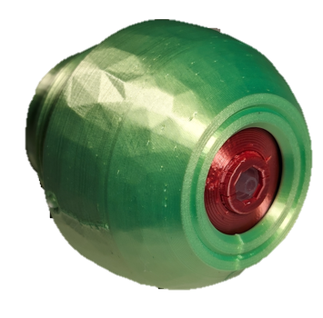

#### Step E-08: Insert the Tee Nut

Insert the Tee Nut (E14) into the hole in the Rear Housing. Line up the prongs with the slots and press the Tee Nut into the Rear Housing until the bottom is flush.

Note: Once the Tee Nut is aligned, a ¼-20 UNC bolt or machine screw can help pull the Tee Nut down into place. Insert the bolt or machine screw into the Tee Nut and tighten until the bottom of Tee Nut is flush with the bottom of the print. Make sure to remove the bolt once the Tee Nut is installed.

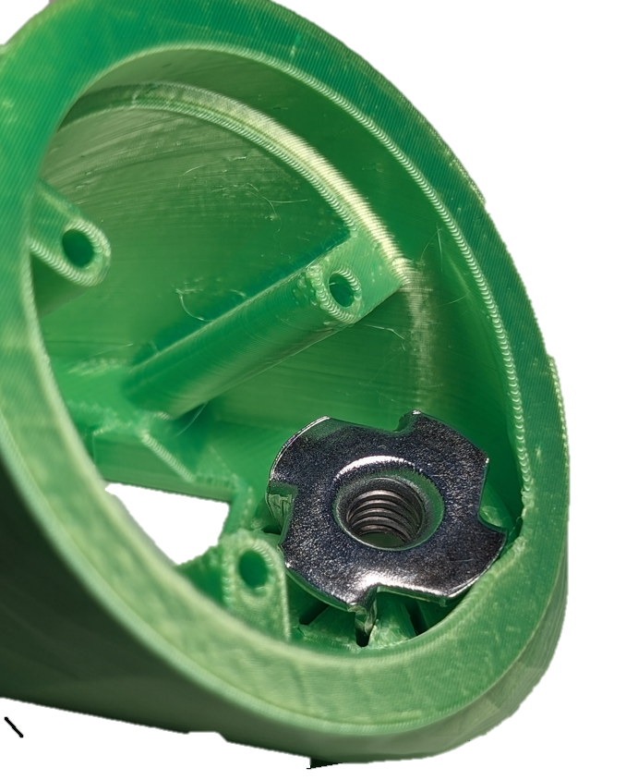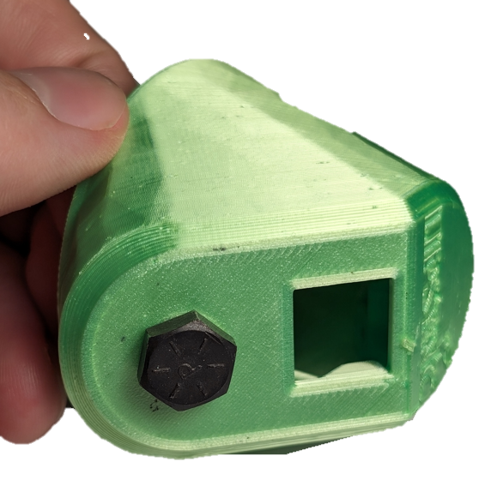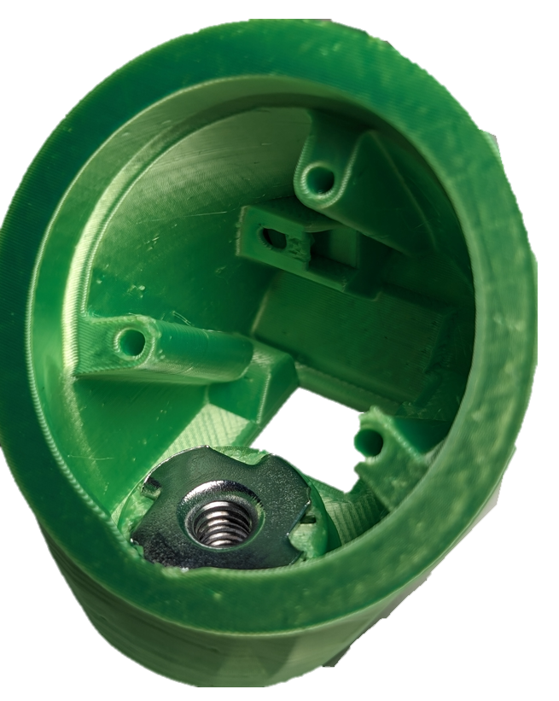

#### Step E-09: Prepare the RJ11 Breakout Board

Separate the two RJ11 breakout boards (E9) by snapping them apart by hand. Make sure the thin portion with the two mounting hole remains attached.

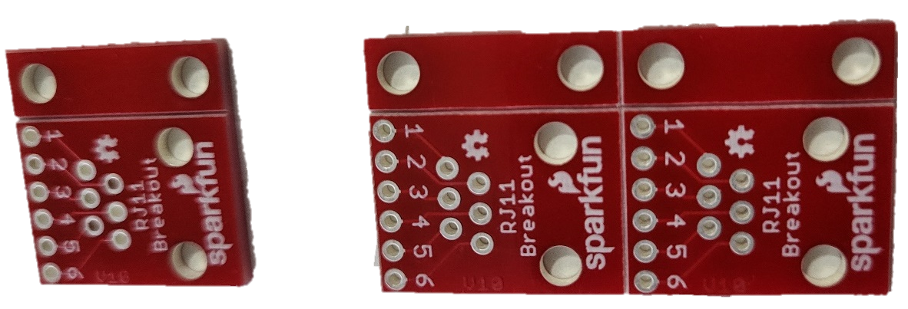

#### Step E-10: Solder the RJ11 jack to the RJ11 Breakout Board

Press the RJ11 Jack (E8) into the breakout board so the pins stick out of the numbered side. Solder the six RJ11 pins poking through the board, **NOT THE NUMBERED HOLES.**

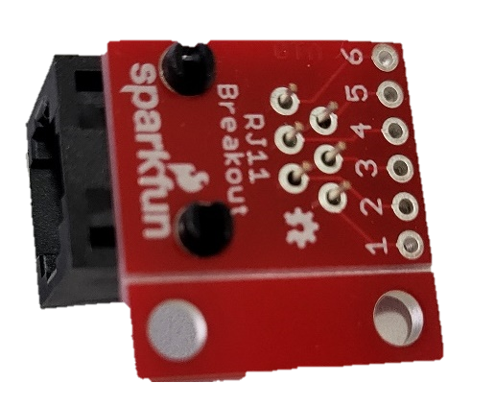

#### Step E-11: Solder the STEMMA QT Cable to the RJ11 Breakout Board

Insert the DuPont headers on the Stemma-Dupont connector (E7) into the through holes on the RJ11 Breakout Board from the same side as the RJ11 Connector, following the order in the table. Solder in place, and trim the DuPont ends sticking out the back side.

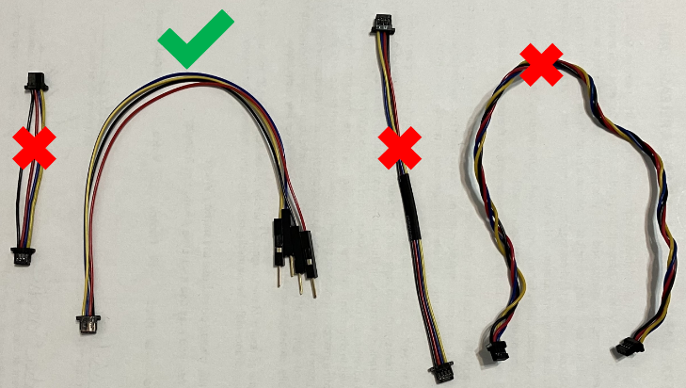

|  |  |
| --- | --- |
| **RJ 11 Breakout** | **STEMMA QT Cable** |
| 2 (B) | Black (Gnd) |
| 3 (R) | Red (Vcc) |
| 4 (G) | Blue (SDA) |
| 5 (Y) | Yellow (SCL) |

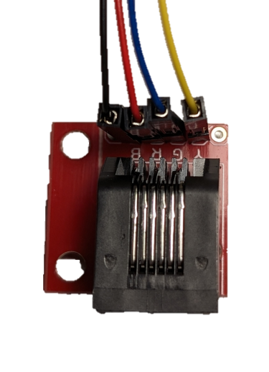

#### Step E-12: Insert the Captive Nut into Rear Housing

Insert a M2.5 nylon nut (E11) into the captive nut slot shown on the Rear Housing (E5).

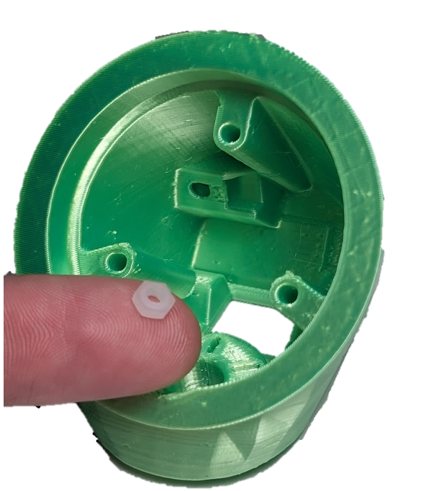

#### Step E-13: Insert and fasten the RJ11 Breakout Board into the Rear Housing

Slide the RJ11 Breakout Board in the slot in the back of the Rear Housing. Secure it in place with a nylon M2.5 machine screw (E10) into the captive nut.

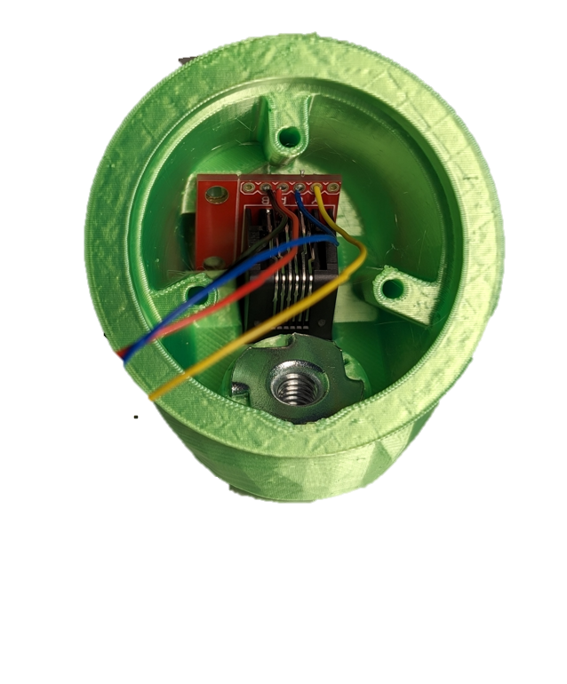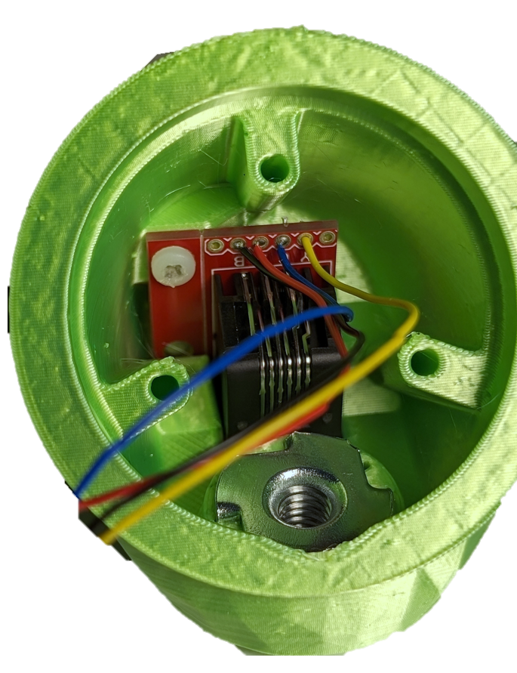

#### Step E-14: Nest the locking rings

Take the Inner (E3) and Outer (E4) Locking Rings, and pass the Inner Ring through the Outer Ring until it has gone as far as it can go as seen in the below photos. The flat print face should be facing the same direction on each piece. The Inner Ring has a tab, and the Outer Ring has a slot. The only way for the rings to fit together is for the tab on the Inner Ring to be aligned with the slot on the Outer Ring, as seen in the photos.

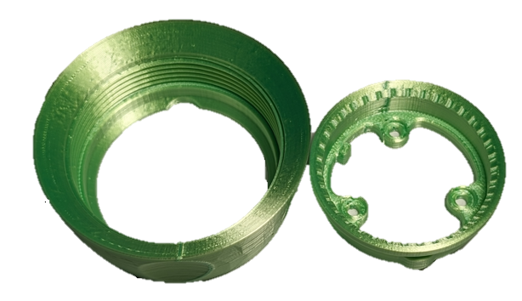

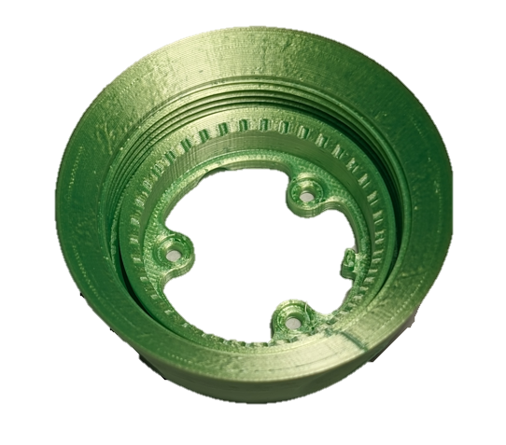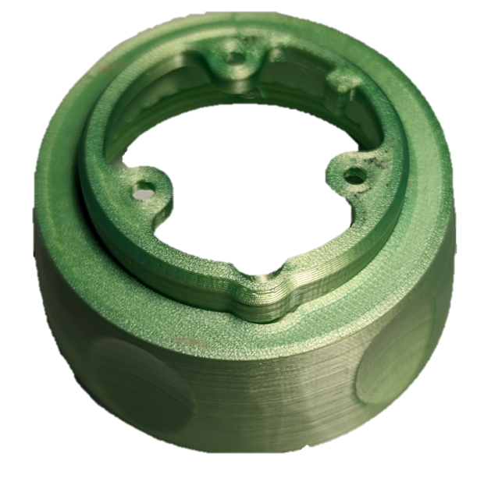

#### Step E-15: Fasten Locking Rings to Rear Housing

As with the previous step, there is a slot on the rear housing that lines up with the tab on the Inner Locking Ring. If this is done correctly, the three holes on the inner ring will line up with the three holes on the rear housing. Using #4 3/8 (E15) screws, fasten the locking rings onto the rear housing.

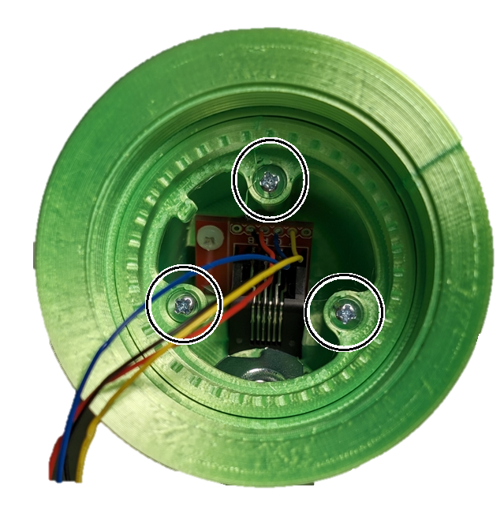

#### Step E-16: Connect the Dupont to Stemma cable to the Ambient Pressure Sensor Board.

Plug the STEMMA QT end of the STEMMA-DuPont cable into the open port of the LPS22 board at the rear of the joystick housing.

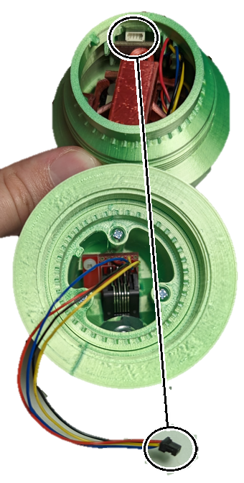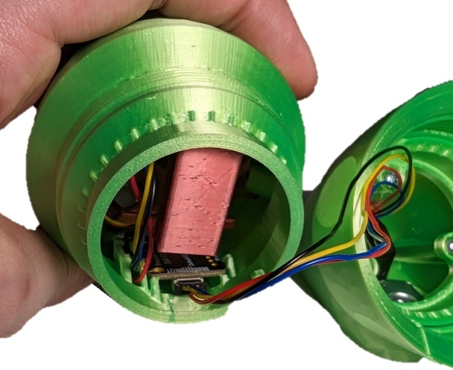

#### Step E-17: Connect the two halves of the Joystick Housing

Screw the locking ring from the back section of the enclosure to the threads on the front half of the enclosure. Tighten the locking ring until the two halves are locked together. Be careful to not rotate the two halves relative to each other so the STEMMA-DuPont cable does not get twisted.

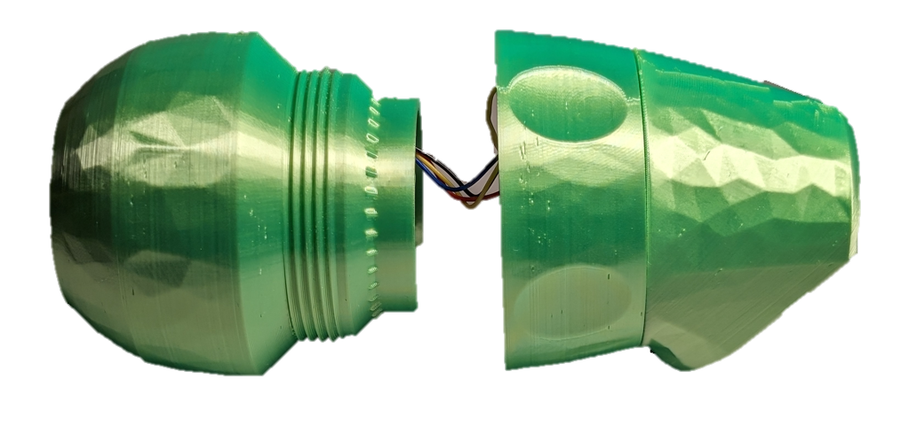

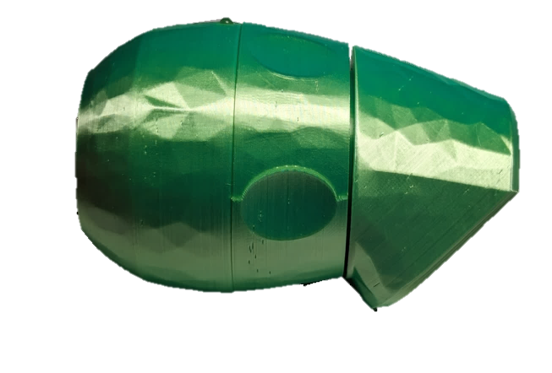

#### Part E Complete: Joystick Unit Assembled

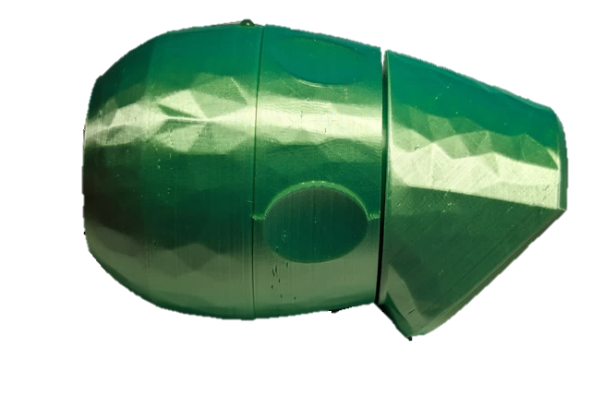

## Part F: Flashing Firmware to Hub

### Part F: Components

|  |  |  |  |  |  |  |  |  |  |
| --- | --- | --- | --- | --- | --- | --- | --- | --- | --- |
| **F1** | LipSync Joystick | | QTY 1 | **F2** | LipSync Hub | QTY 1 | **F3** | RJ11 Cable | QTY 1 |
| The completed, assembled LipSync in a side view | | | | Fully assembled LipSync Hub | | | A picture of the RJ11 cable | | |
| **F4** | USB-C-USB-A Cable | QTY 1 | |
| A photo of a black USB-C cable on a white background. | | | |

### Part F: Tools

* Computer with Arduino IDE to flash firmware

### Part F: Firmware Flashing Steps

#### Step F-01: Connect the LipSync Joystick To The Hub

Plug in the Joystick (F1) to the Hub (F2) using the RJ 11 (F3) Cable.

#### Step F-02: Connect the LipSync Hub to the Computer

Plug in the Hub (F2) to a computer via USB Cable (F4).

#### Step F-03: Setup Arduino IDE on Computer

1. Download Arduino IDE for your operating system at <https://www.arduino.cc/en/software>
2. Install the Arduino IDE.

#### Step F-04: Setup Arduino IDE for Seed Studio Xiao nRF52840 Development Board

1. Open Arduino IDE.
2. Click on **File -> Preferences**.
3. Locate the text field that says **Additional Boards Manager URLs** beside it.
4. Copy and paste the following link into the field as a new line:

<https://files.seeedstudio.com/arduino/package_seeeduino_boards_index.json>

1. Click on **OK.**
2. Restart the Arduino IDE.
3. Open the **Boards Manager** option from the **Tools-> Board-> Boards Manager...,**
4. **Search for “Seeed nrf52” and select “Seeed nRF52 Boards” by Seeed Studio.**
5. **Click Install to install the board.**

#### ****Step F-05: Install Libraries****

1. In the Arduino IDE, go to **Tools -> Manage Libraries…**
2. For each of the libraries in the table below, search for the name, and click Install. If prompted to install any dependent libraries, click OK.

|  |  |  |
| --- | --- | --- |
| Index | Name | Author |
| 2 | Adafruit_LPS2X | Adafruit |
| 3 | Adafruit_LPS35HW | Adafruit |
| 4 | Adafruit_SSD1306 | Adafruit |
| 5 | ArduinoJson | Benoit Blanchon |
| 6 | TLV493D-A1B6 | Infineon Technologies |

#### Step F-06: Setup Local Code Directory

1. Download the Firmware_Files from the GitHub Repository: <https://github.com/makersmakingchange/LipSync/blob/main/Build_Files/Firmware_Files/LipSync_Firmware.zip>
2. Extract / unzip the folder to a known location.
3. Confirm that you have the following folder structure:

* LipSync_Firmware (folder)
  + LipSync_Firmware.ino
  + LSAPI.ino
  + LSTest.ino
  + LSBLE.h
  + LSBuzzer.h
  + LSCircularBuffer.h
  + LSConfig.h
  + LSInput.h
  + LSJoystick.h
  + LSMemory.h
  + LSOutput.h
  + LSPressure.h
  + LSScreen.h
  + LSTimer.h
  + LSUSB.h
  + LSUtils.h

#### Step F-07: Upload the Code to the microcontroller.

1. Open LipSync_Firmware.ino with Arduino IDE.
2. **Select Seeed Xiao NRF52840 from Tools -> Board -> Seeed NRF52 Boards**
3. Connect the LipSync using the USB cable to the computer.
4. Select the correct port from **Tools -> Port** menu.
5. Verify and upload the code.

## Part G: Initial LipSync Setup and Testing

### Part G: Components

|  |  |  |  |  |  |  |  |  |
| --- | --- | --- | --- | --- | --- | --- | --- | --- |
| **G1** | LipSync System | QTY 1 | **G2** | LipSync Mouthpiece | QTY 1 | **G3** | Host Device | QTY 1 |
| A almost fully assembled LipSync joystick and hub, without the mouthpiece | | | The finished mouthpiece assembly | | | Laptop outline | | |

### Part G: Initial LipSync Setup Steps

#### Step G-01: Connect the Mouthpiece to the Joystick

Hold the mouthpiece (G2) by the outer edge of the filter, put it in the Luer connector on the LipSync (G1) and twist to make a connection. Twist until finger tight.

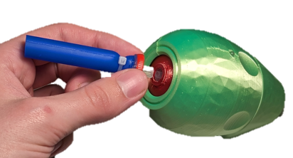

#### Step G-02: Connect the LipSync to Host Device using USB Cable

1. Plug in the Joystick to the Hub via the RJ 11 Cable.
2. Plug in the Hub to a computer via USB cable.
3. The Hub should power on with a startup tone and display the current code version and operating mode on the Hub display screen.

#### Step G-03: Calibrate the Joystick

NOTE: Use either a spare mouthpiece or filter to perform the calibration to ensure the user receives a clean mouthpiece.

1. Enter the settings menu by:
   1. Short press (<1 seconds) Next and Select on the Hub simultaneously.
   2. Holding down the “Next” button on the Hub for at least five seconds.
2. Use the “Next” and “Select” buttons to navigate to the Calibrate menu and select it.
3. In the submenu, select “Full Calibration” and follow the prompts that appear on the Hub Display to calibrate the joystick. Detailed instructions can be found in the User Guide.

### Troubleshooting

1. **My Arduino IDE is stuck when uploading code to the board.**

You can first try to reset the board by clicking the "Reset Button" once. If that does not work, rapidly click it twice to enter bootloader mode. If that also doesn't work, disconnect the board from the PC, and connect the board again.

1. **My board is not showing up as a serial device on Arduino IDE.**

You can first try to reset the board by clicking the "Reset Button" once. If that does not work, rapidly click it twice to enter bootloader mode.

1. **My LipSync won’t turn on after flashing the code and plugging it in to the host device.**

Ensure that the LipSync is connected to a power supply via USB and ensure that the joystick is plugged into the Hub via RJ11 Cable. The LipSync Hub will not turn on unless the joystick is connected.

## Part H: Hub Stand Assembly

### Part H: Components

|  |  |  |  |  |  |  |  |  |
| --- | --- | --- | --- | --- | --- | --- | --- | --- |
| **H1** | LS4_Hub_Stand_Front | QTY 1 | **H2** | LS4_Hub_Stand_Leg | QTY 2 | **H3** | LipSync Hub | QTY 1 |
| The front of the hub stand, printed in red | | | A leg of the hub stand, printed in red | | | Fully assembled LipSync Hub | | |

### Part H: Hub Assembly Steps

Optionally, the LipSync Hub Modular Mounting System can be used to replace this fixed angle hub stand.

#### Step H-01: Clip the legs to the front of the stand

Take the legs (H2) and clip them into the slots on the back of the stand front (H1). The short end of the leg clips into the top of the stand, by the tab for the bolt, and the long end of the leg clips into the bottom of the stand.

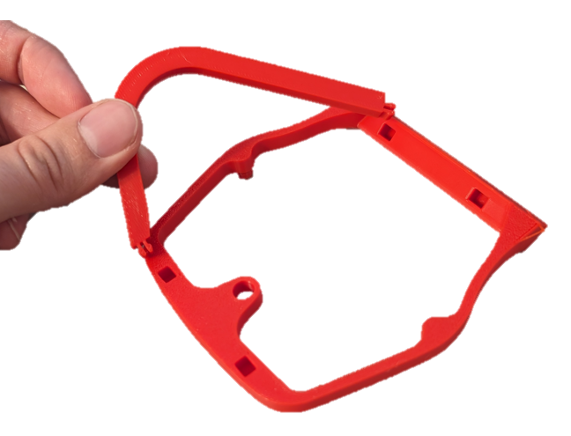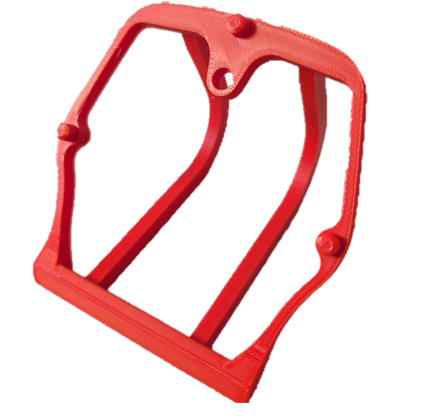

#### Step H-02: Attach the LipSync Hub to the stand

Line up the three posts on the front of the hub stand with the three screw holes on the back of the LipSync Hub. Optionally, for a more secure connection, a ¼-20 bolt can be used to secure the LipSync Hub to the stand.

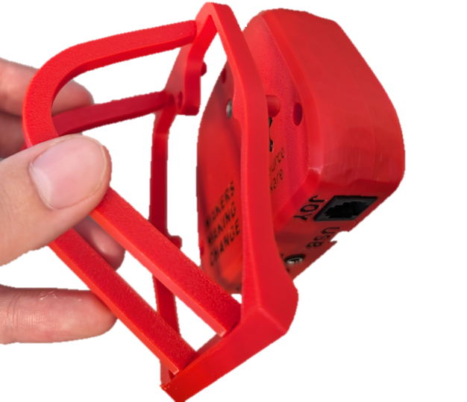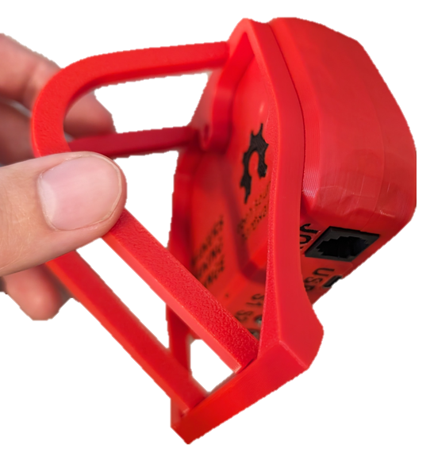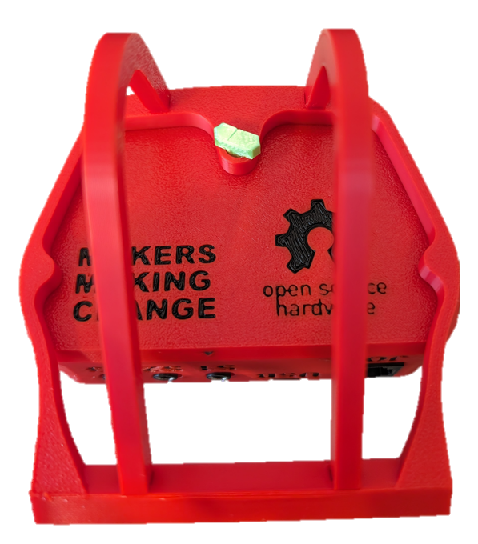

# Testing Guide

After building the LipSync Hub and Joystick, you must verify both units are functioning properly.

## Testing the LipSync

1. Does Display turn on?
   1. Ensure that the LipSync joystick in plugged into the Hub using the RJ11 cable.
      1. Ensure that the LipSync Joystick light pipe lights up green.
   2. If the Hub turns off and does not work, reset the device, and open the serial monitor in Arduino IDE right after resetting to see if one of the STEMMA boards is not being recognised.

### Testing Mouse Mode

Refer to the LipSync User Guide for instructions on how to connect the LipSync to a Host Device and change the operating mode to USB Mouse Mode. When in USB Mouse Mode, ensure moving the joystick moves the mouse cursor. Additionally, test the sip and puff function, external switches, and buttons on the Hub. Ensure that each sip/puff, external switch, and Hub button action are consistent with the following tables.

### Testing Sip and Puff

Install one of the assembled mouthpieces to the LipSync joystick. Once you have tested and confirmed that the sip and puff functions work, **dispose of the mouthpiece you used to test.**

#### Sip

To perform a Sip Input, close your lips around the end of the mouthpiece and sip like you would a drink through a straw (i.e., inhale or apply negative pressure) for less than 1 second and then release. The Right-side Feedback light should blink once after releasing the sip input, and the mouse should perform a right click.

#### Puff

To perform a Puff Input, close your lips around the opening on the mouthpiece and blow air into it (i.e., exhale or apply positive pressure) for less than 1 second and then release. The Left Feedback light should blink once after releasing the puff input, and the mouse should perform a left click.

|  |  |  |  |  |  |  |  |
| --- | --- | --- | --- | --- | --- | --- | --- |
| **LipSync Mouthpiece Input** | Joystick | Short Puff | Long Puff | Very Long Puff | Short Sip | Long Sip | Very Long Sip |
| **Mouse Action** | Cursor Movement | Left click | Start Drag Mode | Enter Hub Menu | Right Click | Start Scroll Mode | Middle Click |

### Testing External Switches

Plug an assistive switch into the external switch jacks and activate the assistive switch. The behaviour for each switch and type of activation is outlined in the table below:

|  |  |  |  |
| --- | --- | --- | --- |
| Input | Mouse | Gamepad | Menu/Settings Mode |
| S1 Short Press | Left Click | Button 1 press | Next |
| S1 Long Press | Start drag mode | Button 3 press | N/A |
| S1 Very Long Press | Enter settings mode | Enter settings Mode | Exit settings mode |
| S2 Short Press | Middle Click | Button 5 press | N/A |
| S2 Long Press | Middle click | Button 6 press | N/A |
| S2 Very Long Press | Perform Center Reset | Perform Center Reset | N/A |
| S3 Short Press | Right Click | Button 2 press | Select menu item |
| S3 Long Press | Start scroll mode | Button 4 press | N/A |
| S3 Very Long Press | Middle click | N/A | N/A |

S1 is the left switch, S2 is the center switch, and S3 is the right switch.

### Testing Hub Buttons

Ensure the following behaviours are consistent when pressing the buttons on the Hub.

|  |  |  |  |  |  |  |  |
| --- | --- | --- | --- | --- | --- | --- | --- |
| **LipSync Hub Button Inputs** | Select Short Press | Select Long Press | Select Very Long Press | Next Short Press | Next Long Press | Next Very Long Press | Next and Select |
| **Mouse Behaviour** | Left Click | Start Drag Mode | Enter Hub Menu | Right Click | Start Scroll Mode | Middle Click | Next and Select |

#### Input Feedback

Each LED is designated to a set of inputs:

**Left LED** •: Puff, Next (Hub), S1

**Middle LED** ••: S2

**Right LED** •••: Sip, Sel (Hub), S3

The time durations Short, Long, and Very Long for the Sip/Puff and switch/button inputs are the following:

**Short**: Less than 1 seconds. Indicated by the respective LED blinking once.

**Long**: Between 1 to 3 seconds. Indicated by the respective LED flashing slowing.

**Very Long**: 3 seconds or longer. Indicated by the respective LED flashing quickly.

Ensure the LEDs behave as outlined above.